GARBAGE-GUARD: DEVELOPMENT OF COMPUTER VISION FOR CREEKS GARBAGE DETECTION USING CONVOLUTIONAL NEURAL NETWORK

A Capstone Study

Presented to the Faculty of the
ELECTRONICS ENGINEERING TECHNOLOGY DEPARTMENT
College of Industrial Technology
Technological University of the Philippines
Ayala Boulevard, Ermita, Manila

by

BRIAN JAY CELESTE
GENESIS WALTER D. REYES II
JADE C. GUNAYAN
KING PERTH G. PEPITO
RODEL S. BANOGBANOG

In Partial Fulfillment for the Requirements of the Degree
Bachelor of Engineering Technology major in Computer Engineering Technology

August, 2026
TABLE OF CONTENTS
TABLE OF CONTENTS ii
LIST OF FIGURES iv
LIST OF TABLES vi
LIST OF ABBREVIATIONS vii
I. INTRODUCTION 1
1.1 Background of the Study 1
1.2 Objectives of the Study 4
1.3 Scope and Limitations of the Study 5
II. LITERATURE REVIEW 7
2.1 Conceptual Framework of the Study 7
2.2 Review of Related Literature and Studies 9
2.3 Review of Related Patents 29
2.4 Synthesis of the Review 40
III. METHODOLOGY 43
3.1 Project Design 43
3.2 Block Diagram 45
3.3 Flowchart 47
3.4 Component Materials 49
3.5 Project Development 61
IV. RESULTS AND DISCUSSION 79
4.1 Project Description 79
4.2 Project Structure 80
4.3 Project Capabilities and Limitations 81
4.4 Test Case Results 82
4.5 System Flow Test Results 83
4.6 Field Deployment Results 84
4.7 Evaluation Results 85
V. SUMMARY OF FINDINGS, CONCLUSIONS, AND RECOMMENDATIONS 86
5.1 Summary of Findings 86
5.2 Conclusions 87
5.3 Recommendations 88
VI. REFERENCES 89
VII. APPENDICES 94
VIII. STUDENTS’ BIONOTE 95

LIST OF FIGURES
Figure 1. Conceptual Framework of Garbage-Guard 7
Figure 2. Cumulative Contribution of Rivers to Global Plastic Emission 10
Figure 3. Municipal Solid Waste against Gross Domestic Product per Capita 12
Figure 4. Weathering and Fragmentation of Plastic in the Marine Environment 13
Figure 5. Floating Objects Detected on a Water Surface 14
Figure 6. Success Rates of Visual Tracking Algorithms on a Benchmark Set 15
Figure 7. Detection and Tracking Pipeline for River-Floating Waste 16
Figure 8. Detection Accuracy in the Laboratory Compared with the Field 17
Figure 9. Floating Litter Images with True and Predicted Labels 18
Figure 10. Ground Truth Compared with Model Output for Three Waste Classes 19
Figure 11. Overhead Imagery of the Kind Used for Object Detection 21
Figure 12. Architecture of the YOLOv8 Detector 22
Figure 13. Selection of Studies for a Systematic Review of Air Quality Monitoring 25
Figure 14. Water Level and Pressure Recorded during a Rainfall Event 27
Figure 15. Neuro-Fuzzy Network for Flood Forecasting 28
Figure 16. Garbage Detection Method, Related Equipment and Device (Li & Wang, 2020) 30
Figure 17. Vision garbage classification system and classification method based on TensorFlow (Wu et al., 2019) 31
Figure 18. WCM-Smart City: WASTE COLLECTION AND MANAGEMENT UNDER SMART CITY USING IOT (Chordiya et al., 2020) 32
Figure 19. Cleaning Unit Using Deep Learning for Floating Trash Detection (Kim et al., 2019) 33
Figure 20. System for Monitoring Water Drainage. (Den Hartog & Voncken, 2017) 34
Figure 21. Drainage Monitoring Apparatus and System (Campbell et al., 2022) 35
Figure 22. Detection and Monitoring of Waste Disposal Using Artificial Intelligence. (Liu et al., 2022) 36
Figure 23. Flood Warning System (Torres et al., 2024) 37
Figure 24. Method and System for Flood Early Warning in Smart Cities Based on the Internet of Things (Shao et al., 2023) 38
Figure 25. Apparatus and method for waste monitoring and analysis (Balachandran & Talavera, 2023) 39
Figure 26. Garbage-Guard’s System Architecture 43
Figure 27. System Flow of the Waste Detection System 45
Figure 28. Garbage-Guard’s System Flowchart 47
Figure 29. Raspberry Pi 5 Single-Board Computer 49
Figure 30. Hikvision HiWatch HWI-B140H Bullet Network Camera 50
Figure 31. Waveshare UPS HAT (E) with Four Battery Bays 51
Figure 32. Raspberry Pi Active Cooler Fitted to a Raspberry Pi 5 53
Figure 33. SanDisk High Endurance 64 GB microSD Card 54
Figure 34. KingSpec M.2 2242 NVMe Solid-State Drive 55
Figure 35. Waveshare PCIe to 2-Channel M.2 Adapter 55
Figure 36. V-Model SDLC Model 61
Figure 37. Model Training and Deployment Pipeline 62
Figure 38. Garbage-Guard’s Gantt Chart 94
LIST OF TABLES
Table 1. Table of Related Patents 29
Table 2. Proposed Solution Matrix 41
Table 3. ISO/IEC 25010:2023-based Metrics Descriptions and Scale of Measurements for Garbage-Guard 65
Table 4. Unit Testing Cases for Controlled Environment Evaluation 69
Table 5. System Testing Cases for Real-World Environmental Conditions 71
Table 6. Acceptance Testing Evaluation Test Cases 75
Table 7. Developer-Side Internal Acceptance Indicators 76
Table 8. End User Side Acceptance Survey Indicators 77
Table 9. Five-Point Likert Scale and Interpretation of the Weighted Mean 78
LIST OF ABBREVIATIONS
Abbreviation Definition
AI Artificial Intelligence
CCTV Closed-Circuit Television
CNN Convolutional Neural Network
GPIO General-Purpose Input/Output
HAT Hardware Attached on Top
IEC International Electrotechnical Commission
IoT Internet of Things
IPO Input-Process-Output
ISO International Organization for Standardization
mAP Mean Average Precision
NCNN Neural network inference framework for mobile and embedded devices
PCIe Peripheral Component Interconnect Express
ROI Region of Interest
RRL Review of Related Literature
RTSP Real-Time Streaming Protocol
SDLC Software Development Life Cycle
SSD Solid-State Drive
UNEP United Nations Environment Programme
UN-SDG United Nations - Sustainable Development Goals
UPS Uninterruptible Power Supply
YOLO You Only Look Once
YOLO26n You Only Look Once version 26 nano

I. INTRODUCTION

1.1 Background of the Study
Urban waterways such as rivers and creeks have an essential role in urban cities because they work as natural drainage systems, ecological home for animals, and pathways that make water flow easy in these cities. However, the fast growth of cities and rising population numbers have led to a major increase in solid garbage generation throughout many countries around the world, most importantly the Philippines. In urban cities around the country, tons of solid garbage are produced daily, and a portion of that garbage ends up in waterways due to poor disposal habits and inefficient garbage collection methods (Development Asia, 2024; UNEP, 2023; World Bank, 2022). Creeks and rivers are an example of major pathways for delivering garbage from areas such as land to sea environments, making them very important points for monitoring pollution (UNEP, 2023; Acot et al., 2022; World Bank, 2022).
One of the major problems about the environment affecting urban creeks is the ongoing collection of solid garbage, including plastics and other non-biodegradable materials. In many urban areas, garbage that has been discarded often add up in waterways and block the natural water flow. Studies have shown that riverbanks and waterways tend to contain the highest level of garbage debris compared with other environments because they act as collection points for floating garbage (UNEP, 2023; Acot et al., 2022; Meijer et al., 2021; World Bank, 2022). In the Philippines, creeks and rivers regularly receive trash from different communities that contribute to water pollution and environmental degradation (Meijer et al., 2021; Robles & Monjardin, 2025; Victoriano et al., 2022). As garbage builds up in these waterways, it also increases the risk of flooding because of the drainage channels being blocked off, reducing waterflow.
The amount of garbage in creeks is often caused by a couple of factors such as bad garbage practices and insufficient garbage management. Research shows that poor performance of solid garbage management programs and lack of awareness contribute strongly to the persistence of garbage pollution in rivers and creeks (Development Asia, 2024; UNEP, 2023; World Bank, 2022). People dispose of their garbage from their homes and their activities by dumping it straight into drainage systems and waterways which eventually lead to creeks and rivers. These factors highlight the need for improved monitoring and garbage management strategies.
Several studies and approaches have been made to monitor garbage pollution and detect garbage buildup in waterways. Traditional ways often rely on manual inspections, which can be a hassle and time consuming, especially in large areas (Robles & Monjardin, 2025; Magyar et al., 2023; Victoriano et al., 2022). Advances in artificial intelligence and computer vision have made these tools widely used for detecting specific objects, especially for environmental monitoring. You Only Look Once (YOLO), is an example of these real-time detection algorithms (Murat & Kiran, 2025; Yaseen, 2024; Kang et al., 2022). Although technologies like this have been applied to monitoring systems, many existing garbage detection solutions rely on satellite imagery or very large datasets that are not really designed for monitoring in waterways such as creeks.
To address these limits, combining computer vision, deep learning and real-time monitoring offers a strong approach to improving garbage detection in creeks. YOLO can analyze video feeds from cameras and can detect garbage materials automatically with good accuracy. This technology can be combined with other platforms that allow environmental managers to monitor the amount of garbage and respond quickly to environmental hazards. This study proposes Garbage-Guard, which applies object detection to a camera feed to identify floating garbage in creeks, count how much has built up, and alert the people responsible once it reaches a set level.
The research aligns with three UN-SDG which include Goal 6, 9, and 11: (Clean Water and Sanitation), (Industry Innovation and Infrastructure), and (Sustainable Cities and Communities) through its implementation of computer vision technologies for urban environmental sustainability (United Nations, 2025).

1.2 Objectives of the Study

General Objective
Development of Computer Vision for Creeks Garbage Detection using Convolutional Neural Network and YOLO26.

Specific Objectives
- To design a computer vision model for creeks garbage detection using a convolutional neural network and YOLO26n, capable of detecting the following, and to evaluate it under Functional Suitability using precision, recall and mAP@0.5 on a held-out test set:
  - Bottles
  - Bags
  - Plastic / Styrofoam Food Container
- To develop a prototype on a Raspberry Pi 5 that detects garbage inside an operator-drawn region of the creek, tracks each item so that its identity stays steady from frame to frame, counts the items present in that region, and triggers an automated alert, shown on a touchscreen dashboard and sent to an Android application, when a customizable threshold (default 20 garbage items) is reached.
- To test the system’s performance using ISO/IEC 25010:2023, specifically the following characteristics:
  - Functional Suitability: The accuracy of object classification and accumulation.
  - Performance Efficiency: The real-time responsiveness of Raspberry Pi 5.
  - Usability: Assessing the system’s operability, user interface, the clarity of accumulation alerts.

1.3 Scope and Limitations of the Study

Scope
This study focuses on the development of Garbage-Guard, an automated, computer vision-based floating garbage detection system deployed on an edge computing device, specifically the Raspberry Pi 5. The primary scope of the system encompasses the following:
- Develop an automated floating garbage detection system, Garbage-Guard, using the YOLO26n algorithm on a Raspberry Pi 5.
- Identify and categorize three specific types of floating solid garbage: Bottles, Bags, and Food Containers.
- Utilize a custom dataset split 70/10/20 into training, validation and test partitions, with a frozen held-out test set, to achieve a precision of at least 80% with recall and mAP@0.5 reported alongside it.
- Execute item-tracking and region-of-interest logic that counts the floating items present in the monitored area, smoothed over recent frames, and triggers an “Accumulation Alert” once a threshold, by default 20 garbage items, is reached; the threshold is customizable.
- Provide a touchscreen dashboard at the unit and an Android application for remote alerts, history and settings.
- Deploy the prototype at a local creek or barangay site for a field deployment of at least four to five days, for real-world environmental testing.
- Deployment of a floating barrier that traps floating surface garbage.
- Evaluate system performance based on ISO/IEC 25010:2023 standards, specifically Functional Suitability, Performance Efficiency and Usability.

Limitations
Despite the capabilities of the Garbage-Guard system, the study is bound by several technical and environmental limitations:
- Detection is limited to items visible on the water's surface; the system cannot identify sunken or heavily obscured garbage.
- Classification is strictly confined to the three target categories (bottles, bags, and food containers) and excludes other pollutants like metal, glass, or organic debris.
- Detection quality depends on camera placement and lighting; very bright or very dim light reduces recognition.
- On the creek-only test images, floating bags were detected far less often than bottles and food containers, with a recall of 0.22 on 20 test images, so the count of bags is likely to be understated.
- The two enclosure case fans run from mains power only, so sustained operation on battery has not been tested for heat.
- Functionality is limited to monitoring and early-warning alerts; it does not include mechanical garbage collection or water quality analysis.

II. LITERATURE REVIEW

2.1 Conceptual Framework of the Study
Figure 1
Conceptual Framework of Garbage-Guard
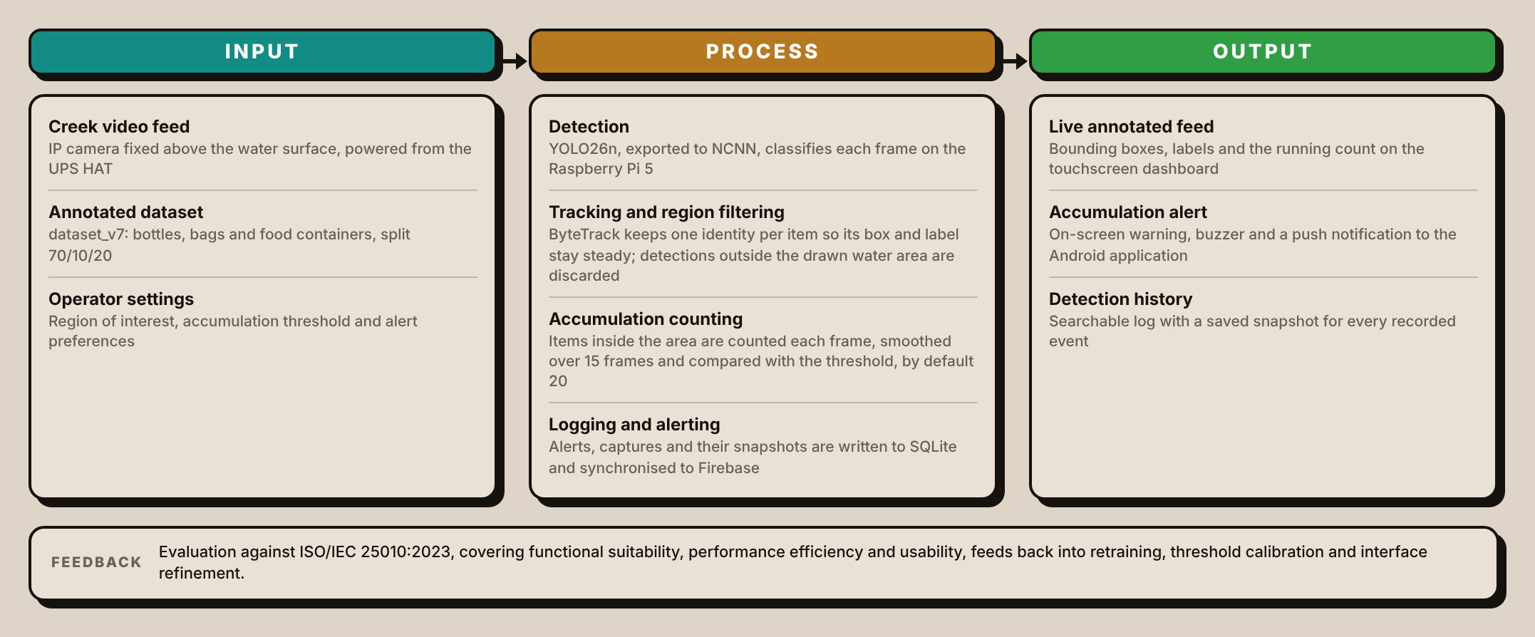
Figure 1 presents the conceptual framework of Garbage-Guard, arranged as an IPO or input-process-output model with a feedback path. The process column is expanded beyond a single detection block so that each point at which a design decision was made is visible, since those decisions are what separate this system from a detector that only labels frames.
Three inputs drive the system. The first is the live video feed from the network camera fixed above the creek surface, which supplies frames continuously rather than on a schedule. The second is the annotated dataset, held in this study as dataset_v7 and split 70/10/20 into training, validation and test partitions across three classes, namely bottles, bags and food containers. The third is the set of operator-supplied settings: the region of interest traced on the water, the accumulation threshold, which defaults to twenty items, and the alert preferences.
Processing runs in four stages on a Raspberry Pi 5. Detection is performed by a YOLO26n convolutional neural network exported to NCNN, the format the board runs fastest. Tracking assigns and holds one identity per object from frame to frame, so each item keeps the same box and label instead of flickering in and out of view. Region filtering then discards any detection whose position falls outside the traced water area, which is what prevents fixed objects on the bank from entering the count. Accumulation counting takes the number of items inside the region in each frame, smooths it as the median of the last fifteen frames so that a single missed or false detection does not move it, and compares the result with the threshold. Logging writes each alert, together with its snapshot, to a local database and synchronizes it to the cloud.
The region filter and the smoothed count deserve emphasis, because they are the difference between a detector and a monitoring system. A detector that reports twenty bounding boxes in a single frame has not established that twenty items are present, since one frame can contain a false detection or miss a real item, and a system that cannot exclude the bank will report a concrete wall as garbage for as long as it remains in view.
The system produces three outputs. The touchscreen dashboard shows the annotated live feed with bounding boxes, class labels and the running count. When the threshold is crossed, an accumulation alert is raised on screen, sounded on the buzzer and pushed to the Android application. Every recorded event is retained in a searchable history with a saved snapshot, which is what allows a reading to be checked after the fact.
Evaluation against ISO/IEC 25010:2023, covering functional suitability, performance efficiency and usability, returns to the input and process stages. Weak per-class results direct further annotation and retraining, measured latency informs the frame sampling rate, and operator comments on the interface feed the dashboard design. The feedback path is drawn because it describes what happened in this study: the detection model passed through eight training runs, v1 to v7 with an extra v6b, and the accumulation threshold is calibrated on site rather than fixed in advance.

2.2 Review of Related Literature and Studies

Environmental Garbage Issues in Philippine Waters
Based on the UNEP (2023) or United Nations Environment Programme, World Bank (2022), and Acot et al. (2022), urban waterways such as rivers and creeks play a critical role in the lives of people living in urban centers. However, due to the effects of rapid urbanization and an ever-increasing population, the amount of solid garbage generated has increased over the years, particularly in the Philippines. The researchers emphasized that a huge volume of garbage generated in the urban area ends up in the waterway due to inappropriate garbage disposal mechanisms. The researchers’ study results revealed that waterways are considered accumulation points for solid garbage originating from the surrounding communities. However, the researchers’ study focused on the garbage management policies and environmental effects rather than the technological aspect. These researchers’ studies are related to the present research because they emphasized the need to monitor garbage pollution in the waterway, such as a creek.

Rivers as the Pathway for Ocean Plastic (Meijer et al., 2021)
According to Meijer et al. (2021), rivers are the pathways that check the transportation of garbage from land to ocean. The research showed global modeling and data finding of environmental data to see sources and pathways of garbage in oceans. The research findings saw that a serious amount of garbage was entering the ocean coming from rivers that are mainly in heavy populated environments. However the research was heavily leaning on data analysis and modeling techniques, which is not effective in checking groups of garbage in creeks. This research is similar to the current study, because it shows the dangers of rivers in the transportation of garbage materials.
Figure 2
Cumulative Contribution of Rivers to Global Plastic Emission
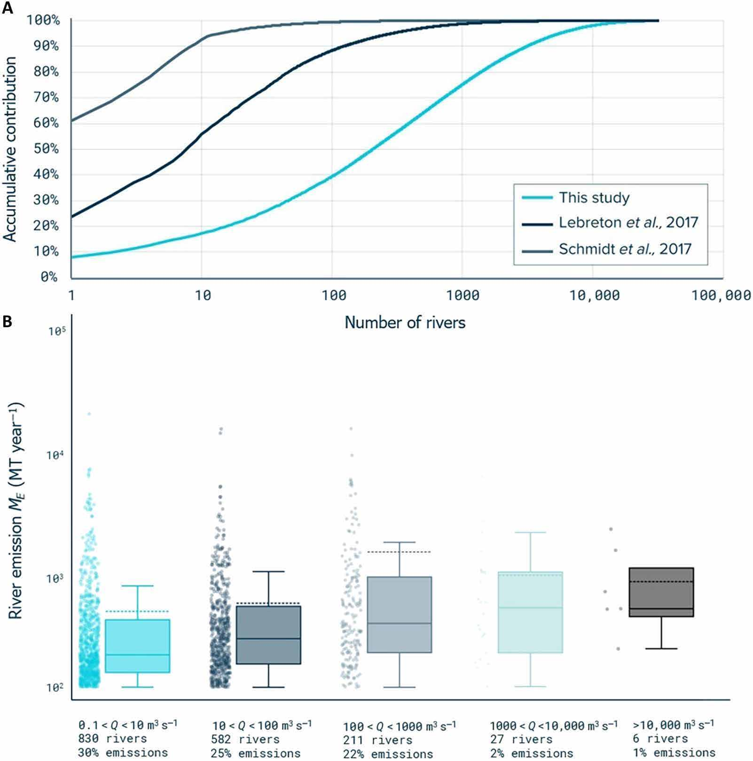
Note. From “More than 1000 rivers account for 80% of global riverine plastic emissions into the ocean,” by L. J. J. Meijer, T. van Emmerik, R. van der Ent, C. Schmidt and L. Lebreton, 2021, Science Advances, 7(18). CC BY-NC.

Mismanaged Plastic Waste and Urban Flooding (MacAfee & Löhr, 2023)
MacAfee and Löhr (2023) checked the interaction of non-organized plastic waste (MPW) and flooding in rapid urbanization and climate change. The review indicates that the rise in the amount of plastic waste in drain channels increases the risks of flooding, especially in coastal cities MacAfee and Löhr (2023). The limitation of the research is based on the fact that it is based on existing literature without offering technological solutions. The research is relevant in the sense that it emphasizes the need for waste monitoring in the prevention of environmental and social hazards.

Identifying Plastic Waste in Marine Ecosystems (Das et al., 2025)
According to Das et al. (2025), the paper “Plastic Waste in Marine Ecosystems: Identification Techniques and Policy Interventions” reviewed a lot of research papers on marine plastic waste, focusing on techniques and policies that can be intervened. The findings showed that polyethylene and polypropylene are main plastic waste, and the best way to identify plastic waste is by using infrared spectroscopy and AI recognition. The limitations of this research is that it only depended on literature studies and not experiments. The research paper is still relevant to the current study because it showed that waste in water can still be managed.

Wastewater Management in the Philippines (Corpuz, 2025)
Corpuz (2025) saw the issues in wastewater management in the Philippines. The research saw issues in waste management such as a growing population and poor treatment facilities. This results in wastewater not being treated, being discharged to water bodies. This research used policy review and environmental review as a research method. The limitation of this research is that there is a lack of technology in monitoring wastewater. This is similar because it shows the importance of water checking systems, an objective of Garbage-Guard.

Solid Waste Management and Economic Growth (Ella et al., 2022)
The study by Ella et al. (2022) on the relationship between municipal solid waste (MSW) management and economic growth in selected OECD countries and the Philippines revealed that MSW has a positive effect on GDP per capita. However, the effect of recycling varies by country. The limitations of the study are its concentration on statistical data rather than real-time waste management. This study is similar because it shows the importance of managing waste.
Figure 3
Municipal Solid Waste against Gross Domestic Product per Capita
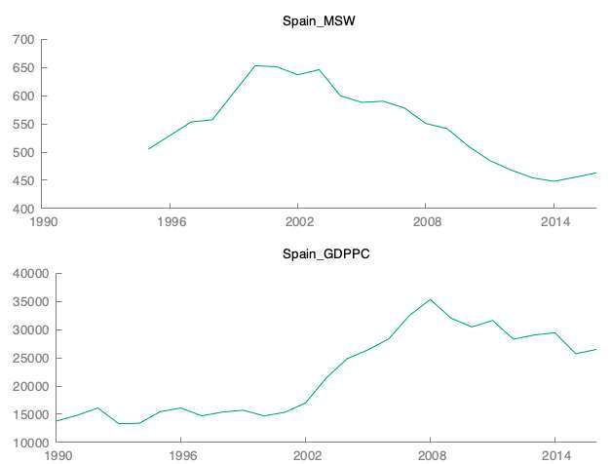
Note. From “The impact of solid waste management to the economic growth in selected OECD countries and Philippines,” by D. M. Ella, D. M. Lim, B. Lu and R. Cabauatan, 2022, Journal of Economics, Finance and Accounting Studies, 4(1). CC BY.

Plastic and Microplastic Waste in Southeast Asia (Ng et al., 2023)
According to Ng et al. (2023) on pollution in Southeast Asia, it is obvious that it lacks structure and poor waste collection practices are bringing an increased level of plastic pollution in water sources. The research earns a review approach and limited citations in data coverage and is dependent on secondary sources. The research is relevant in that it highlights the importance of monitoring and detection of plastic pollution, in which Garbage-Guard helps through computer vision.
Figure 4
Weathering and Fragmentation of Plastic in the Marine Environment
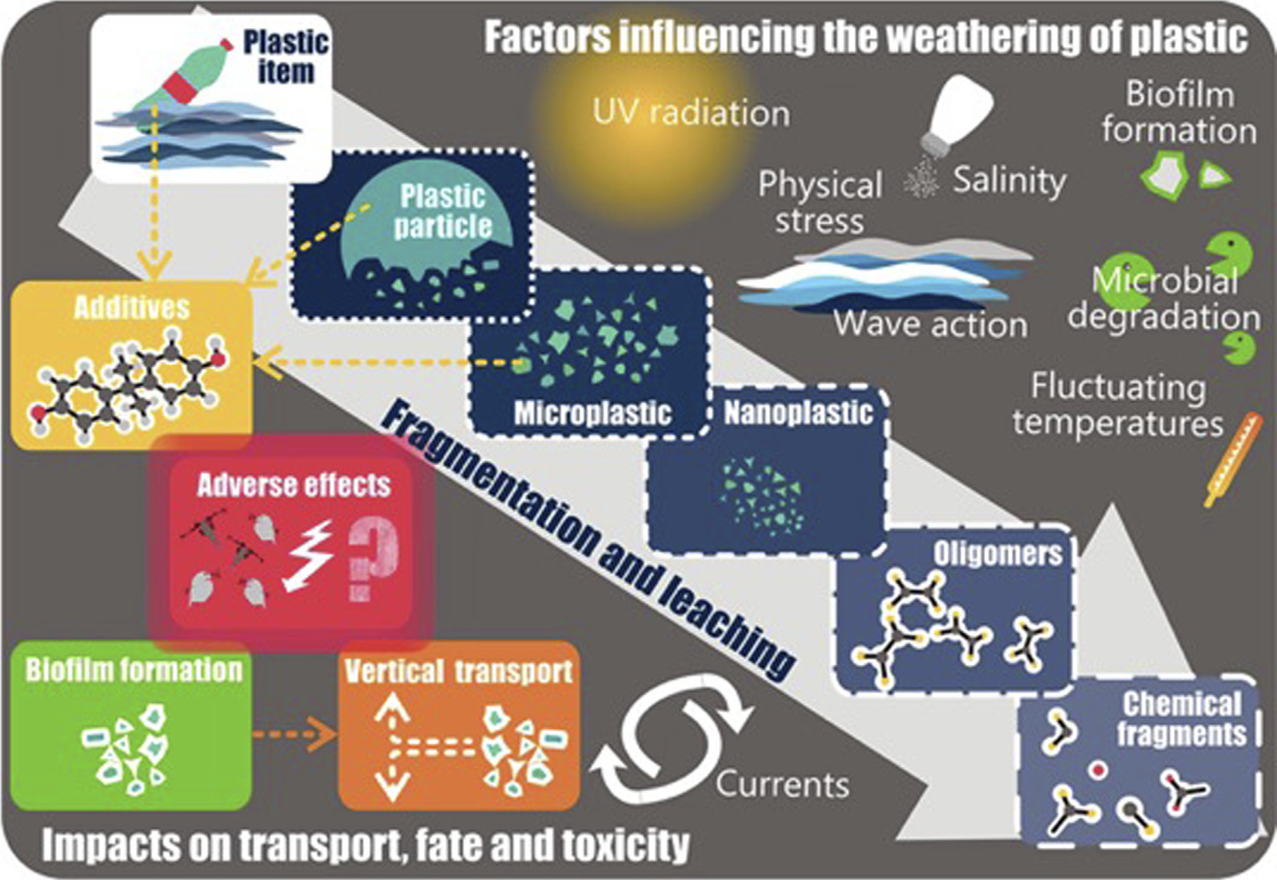
Note. From “Plastic waste and microplastic issues in Southeast Asia,” by C. H. Ng et al., 2023, Frontiers in Environmental Science, 11. CC BY.

Computer Vision Systems

Floating Object Detection on Edge Hardware (Li et al., 2024)
Li et al. (2024) addressed the problem this study also faces, which is running a detector on hardware small enough to sit beside the water rather than in a server room. Their improved YOLOv5s model raised detection accuracy by 15.7 per cent over the baseline, cut false detections on small targets by 83 per cent, and sustained 33 frames per second on an edge device. Two findings carry directly into Garbage-Guard. The first is that a small YOLO variant is sufficient for floating-object detection, which supports the choice of YOLO26n over a heavier model. The second is that accuracy is lost on small and distant objects, which matches the weakness this study observes at the creek, where floating bags are the least reliably detected class.
Figure 5
Floating Objects Detected on a Water Surface
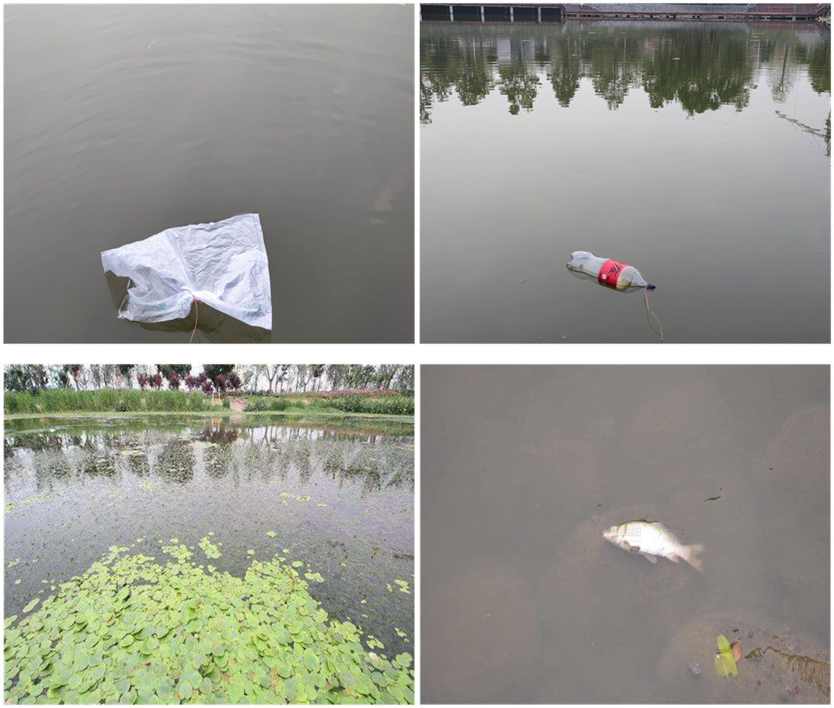
Note. From “Detection of floating objects on water surface using YOLOv5s in an edge computing environment,” by H. Li et al., 2024, Water, 16(1), 86. CC BY.

Computer Vision Detection and Visual SLAM (Chen et al., 2024)
According to the study of Chen et al. (2024), computer vision serves as a foundational element in the realm of intelligent systems and AI technologies. It can effectively replace traditional sensors as the primary source of data input, acting as a pair of intelligent "eyes" that can more adeptly process data sources to drive a range of unmanned operations, such as autonomous driving, obstacle avoidance, and detection tracking. This study is relevant to researchers’ study as we integrate with computer vision to detect waste in creeks in real time.
Figure 6
Success Rates of Visual Tracking Algorithms on a Benchmark Set
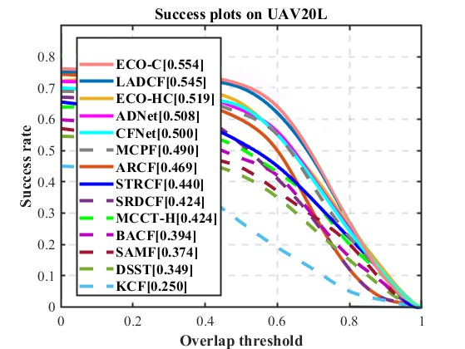
Note. From “A survey of computer vision detection, visual SLAM algorithms, and their applications in energy-efficient autonomous systems,” by L. Chen et al., 2024, Energies, 17(20), 5177. CC BY.

Detecting and Tracking River-Floating Waste (Nunkhaw & Miyamoto, 2024)
Nunkhaw and Miyamoto (2024) combined a YOLOv5 detector with DeepSORT tracking to analyse river-floating waste, reporting a mean average precision at or above 88 per cent and roughly 80 per cent accuracy across three scenarios. Theirs is the closest published precedent for the method used here, because it establishes that detection alone is not enough on moving water. An item drifting through the frame must hold a single identity across successive frames, or it is counted again on every frame in which it appears. Garbage-Guard reaches the same conclusion and resolves it the same way, substituting ByteTrack for DeepSORT.
Figure 7
Detection and Tracking Pipeline for River-Floating Waste
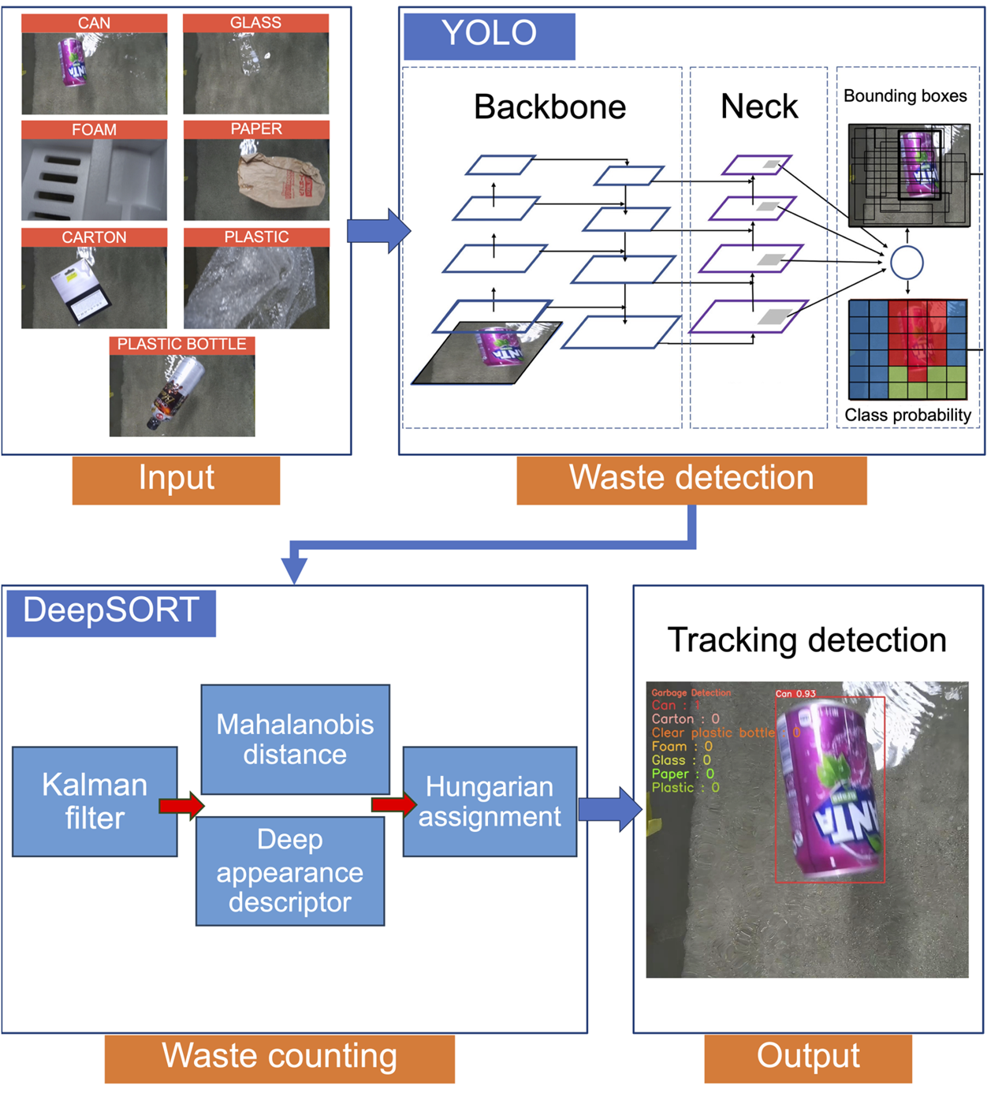
Note. From “An image analysis of river-floating waste materials by using deep learning techniques,” by M. Nunkhaw and H. Miyamoto, 2024, Water, 16(10), 1373. CC BY.

River Waste Detection in Urban Canals (Nunkhaw et al., 2025)
Nunkhaw et al. (2025) extended that work to the urban canals of the Chao Phraya River, training a YOLO detector on laboratory flume images and then adapting it to real canal conditions through a preprocessing pipeline. The study bears on Garbage-Guard in two ways. It is set in Southeast Asian urban waterways, where waste composition and water conditions resemble a Metro Manila creek more closely than European or North American river studies do. It also documents the gap between performance on controlled images and performance in the field, which is the same gap this study reports between its full test partition and its creek-only subset.
Figure 8
Detection Accuracy in the Laboratory Compared with the Field
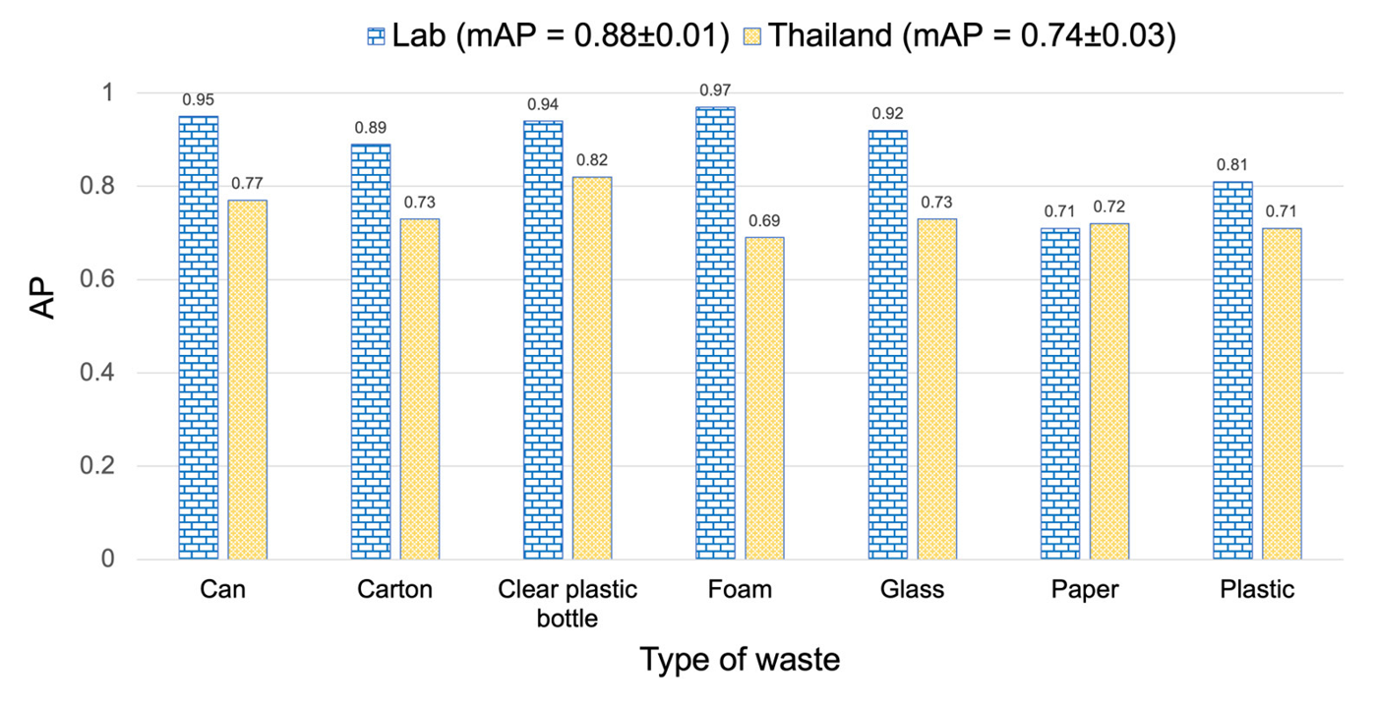
Note. From “Enhancing river waste detection with deep learning and preprocessing: A case study in the urban canals of the Chao Phraya River,” by M. Nunkhaw, D. Chitwatkulsiri and H. Miyamoto, 2025, Water, 17(22), 3193. CC BY.

An Open Dataset for Floating Litter Detection (Jia et al., 2023)
Jia et al. (2023) addressed the shortage of public training data for floating litter by assembling and releasing an open dataset, then measuring what detection performance it supports. The problem they describe is the one that shaped the data collection in this study: no existing dataset covers the particular waste types found in Philippine creeks, so images had to be gathered and annotated locally. Their work provides a published justification for building a custom dataset rather than adapting a general-purpose one.
Figure 9
Floating Litter Images with True and Predicted Labels
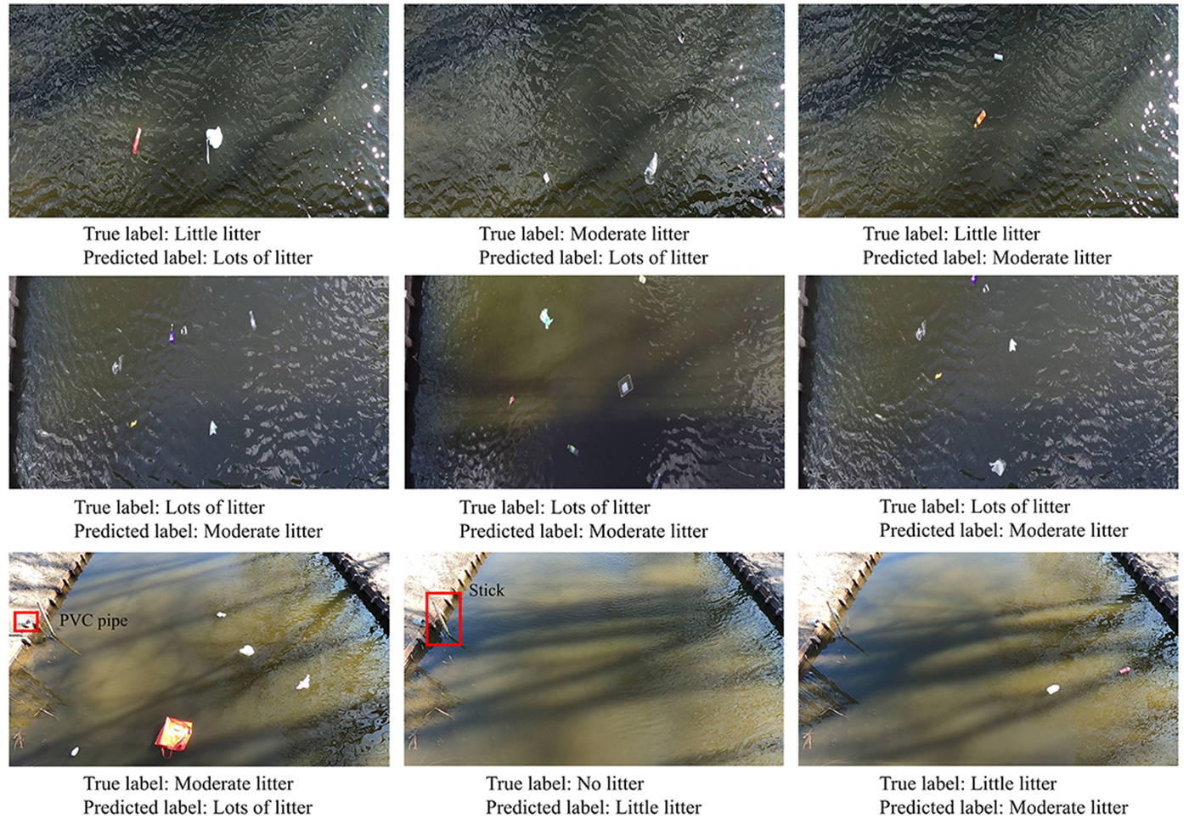
Note. From “Advancing deep learning-based detection of floating litter using a novel open dataset,” by T. Jia, A. J. Vallendar, R. de Vries, Z. Kapelan and R. Taormina, 2023, Frontiers in Water, 5. CC BY.

Segmentation Compared with Detection for Floating Macroplastic (Kataoka et al., 2024)
Kataoka et al. (2024) compared instance segmentation models for floating macroplastic in river surface images. Segmentation returns a precise outline of each object rather than a rectangle around it, which is more informative but considerably more expensive to compute. Their results support the decision taken here to use bounding-box detection instead. For counting accumulation against a threshold, what matters is the position and identity of an item rather than its exact outline, and the computation saved is what allows the model to run on a Raspberry Pi at the waterside.
Figure 10
Ground Truth Compared with Model Output for Three Waste Classes
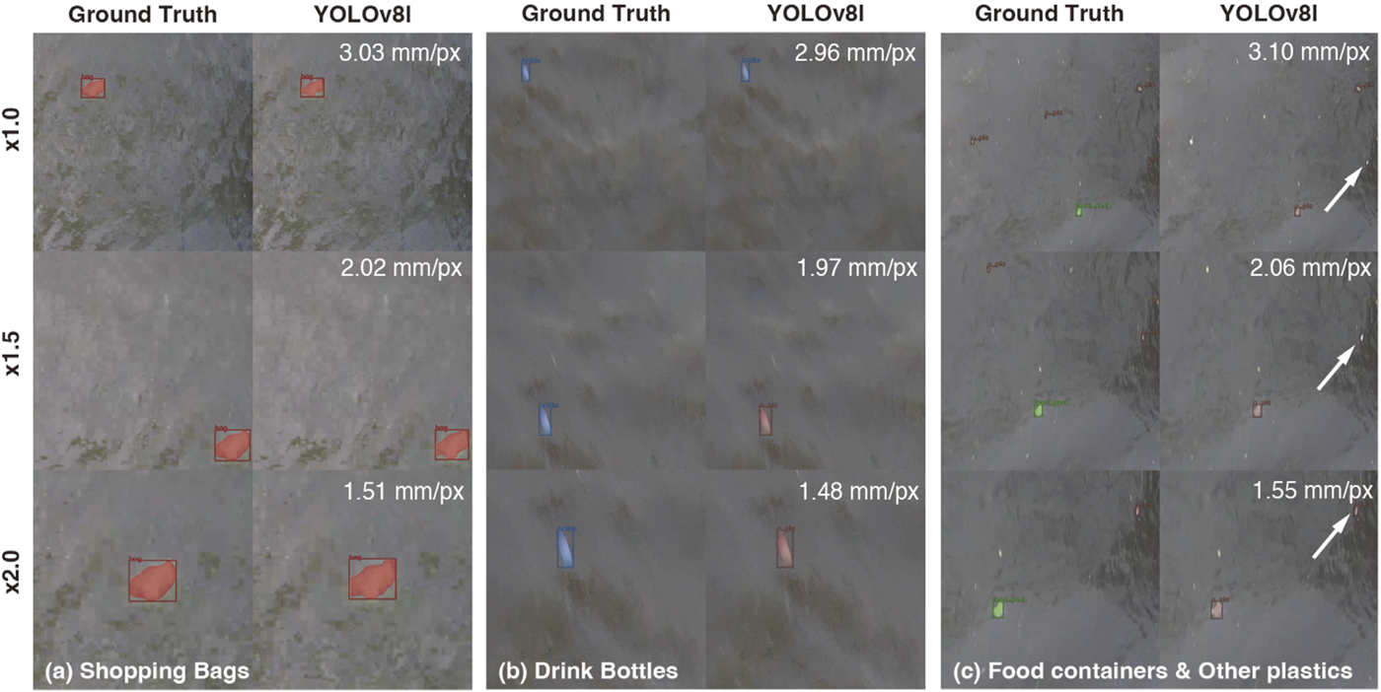
Note. From “Instance segmentation models for detecting floating macroplastic debris from river surface images,” by T. Kataoka, T. Yoshida and N. Yamamoto, 2024, Frontiers in Earth Science, 12. CC BY.

Classifying Waste Fragments with Convolutional Features (Nežerka et al., 2023)
According to the study of Nežerka et al. (2023), to address improper sorting of construction and demolition waste that leads to significant environmental and economic implications, they developed a machine-learning-assisted procedure for recognizing construction and demolition waste fragments using an rgb camera. It resulted in an overall 85.9%, offering a pathway for efficient and accurate waste sorting. It can be relevant to researchers’ study as it relates to detecting waste using computer vision.

Lane Detection under Varying Light (Al Noman et al., 2022)
According to the study of Al Noman et al. (2022) "A computer vision-based lane detection technique using gradient threshold and hue-lightness-saturation value for an autonomous vehicle" the system uses computer vision-based technologies to identify road lines. The left and right lanes on the roads are determined via sliding window searching technique. The system works with 96% accuracy and the positive rate is 0.640%. The accuracy and the efficiency of the system could be developed by increasing computer features and applying deep learning algorithms along with the proposed study.

Object Detection in Overhead Imagery (Kang et al., 2022)
According to Kang et al. (2022), computer vision technology has enhanced the processing of objects in high-resolution overhead images taken by drones, airplanes, and satellites. The technology has been applied in real-world applications like crop analysis, economic analysis, and disaster tracking. Despite the advancements, object detection in overhead images is still a challenge due to the volume of images, resolution, size of objects, and complexity of the background.
Figure 11
Overhead Imagery of the Kind Used for Object Detection
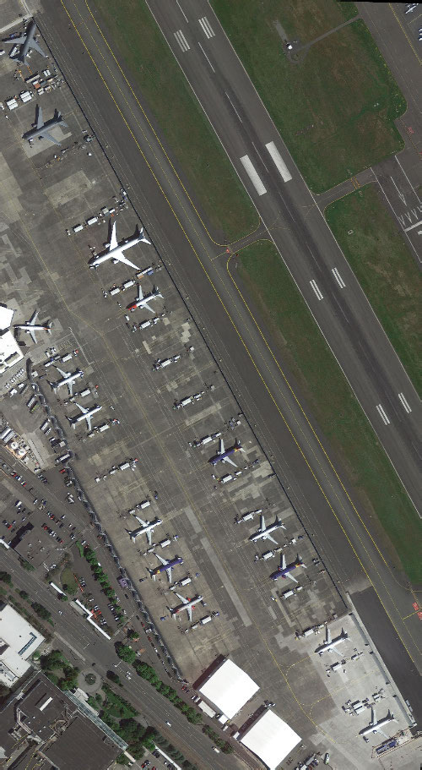
Note. From “A survey of deep learning-based object detection methods and datasets for overhead imagery,” by J. Kang, S. Tariq, H. Oh and S. S. Woo, 2022, IEEE Access, 10. CC BY.

A Review of YOLO Versions for Object Detection (Murat & Kiran, 2025)
Similarly, Murat & Kiran (2025) described that object detection algorithms have undergone a tremendous transformation with the application of deep learning technology. Among the most popular algorithms is YOLO, which is famous for its fast and accurate real-time object detection. The researcher has reviewed the various versions of YOLO, including YOLOv1 to YOLOv11, and described the advancements in the architecture and performance of the algorithm.

The Internal Architecture of YOLOv8 (Yaseen, 2024)
Moreover, Yaseen (2024) has examined YOLOv8 and described the advancements of the algorithm over the previous versions. The algorithm applies advanced architectures such as CSPNet and FPN+PAN, along with an anchor-free technique, to enhance the feature extraction and multi-scale detection. The algorithm has been tested on datasets such as Microsoft COCO, demonstrating the accuracy and real-time detection capabilities of YOLOv8.
Figure 12
Architecture of the YOLOv8 Detector
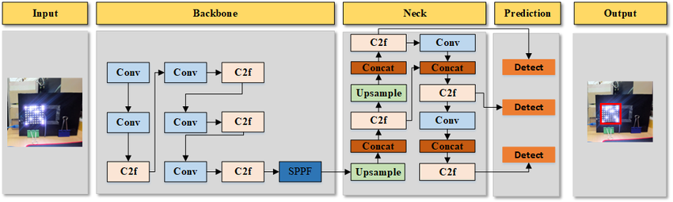
Note. From “What is YOLOv8: An in-depth exploration of the internal features of the next-generation object detector,” by M. Yaseen, 2024, arXiv. CC BY.

Smart Environmental Monitoring Systems

Real-Time Environmental Monitoring with IoT Sensors (Narayana et al., 2024)
In the research conducted by Narayana et al. (2024), environmental conditions are made up of both living and non-living components that affect human life. Non-living components include land, water, stones, and the atmosphere, while living components include organisms such as plants, woodlands, fisheries, and wildlife. Human life, particularly for people who practice activities such as farming, sailing, traveling, and mining, is affected by environmental variables such as temperature, humidity, pressure, air quality, greenhouse gases, wind speed and direction, rainfall, soil pH, soil moisture, water availability, light intensity, and turbidity.
In addition to that, to address the issue of monitoring environmental variables and to mitigate the challenges that come with monitoring environmental parameters, IoT technology was used to develop IoT-based smart environmental monitoring systems. This technology uses microcontrollers and other technologies to monitor environmental parameters from different locations and send the data to a website for monitoring and observation remotely using IoT technology. IoT technology is a dynamic system that observes and responds to environmental variables and conditions (Narayana et al., 2024)

Sensors in Smart City Systems (Zeng et al., 2024)
In the study of Zeng et al. (2024), the integration of IoT technology into smart city systems has several advantages in the management of the environment, as it allows real-time monitoring of important parameters such as air quality, water quality, noise levels, soil quality, and others. This has enabled city administrators to proactively manage the resources of the city in a cost-effective manner. These parameters have collectively proven the importance of IoT sensors in achieving sustainability in the environment.

IoT and Artificial Intelligence in Air Quality Monitoring (Garcia et al., 2025)
Expanding on these capabilities, Garcia et al. (2025) show how Internet of Things (IoT) technologies have greatly improved environmental monitoring by allowing a network of low-cost sensors to continually produce large amounts of real-time data on air quality. This is further enhanced when these IoT systems are used with artificial intelligence techniques such as machine learning and deep learning. This improves the accuracy of environmental evaluations. The IoT-based systems used for monitoring are able to monitor various aspects of air quality, including particulate matter, carbon dioxide, nitrogen dioxide, ozone, and volatile organic compounds. This makes them an efficient means of conducting a thorough surveillance of the environment. This is a clear example of how integrated IoT and artificial intelligence-based systems can improve decision-making regarding environmental management.
Figure 13
Selection of Studies for a Systematic Review of Air Quality Monitoring
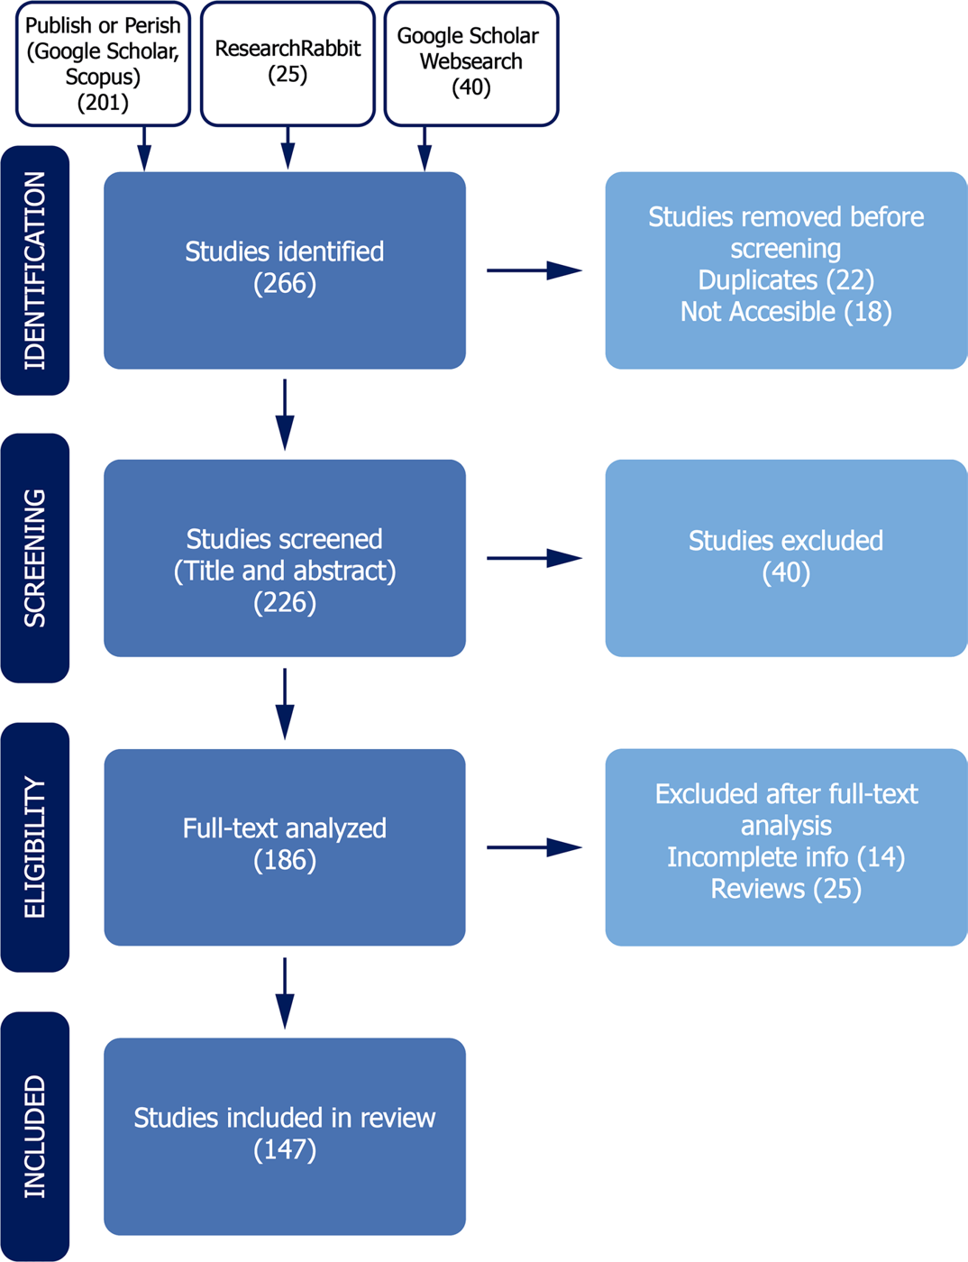
Note. From “Advancements in air quality monitoring: A systematic review of IoT-based air quality monitoring and AI technologies,” by A. Garcia, Y. Saez, I. Harris, X. Huang and E. Collado, 2025, Artificial Intelligence Review, 58. CC BY.

Machine Learning and IoT for Pollution Prediction (Gryech et al., 2024)
In the recent literature of Gryech et al. (2024), it has been observed that there is a rising trend towards the inclusion of IoT technologies with machine learning methods for better outdoor air pollution prediction and forecasting. Though the traditional air pollution stations are accurate, the high cost of these stations has encouraged the development of IoT-based low-cost sensors, along with machine learning methods that are capable of predicting the levels of outdoor air pollution through time-series, feature-based, and spatio-temporal methods, although the limitations of the lack of diversity in the data and the context-specific features have to be addressed, as identified by the recent literature.

Urban Flood Monitoring with LoRaWAN Sensors (Te et al., 2024)
One of the significant environmental issues experienced in the Philippines has been flooding, which has been attributed to monsoon rains, the topography of the area, and inadequate drainage systems. This has been a major cause of loss of lives and properties, especially in the urban area. In order to address the issue of delay associated with flood monitoring, Te et al. (2024) proposed the development of a smart IoT-based flood monitoring system for an urban area. This would entail the incorporation of efficient pressure sensors, LoRaWAN, and solar power. From the reviewed background of the research, it is clear that there is a need to utilize IoT to address the issue of disaster, as it would allow for efficient monitoring to enhance the flood response strategy (Te et al., 2024).
Figure 14
Water Level and Pressure Recorded during a Rainfall Event
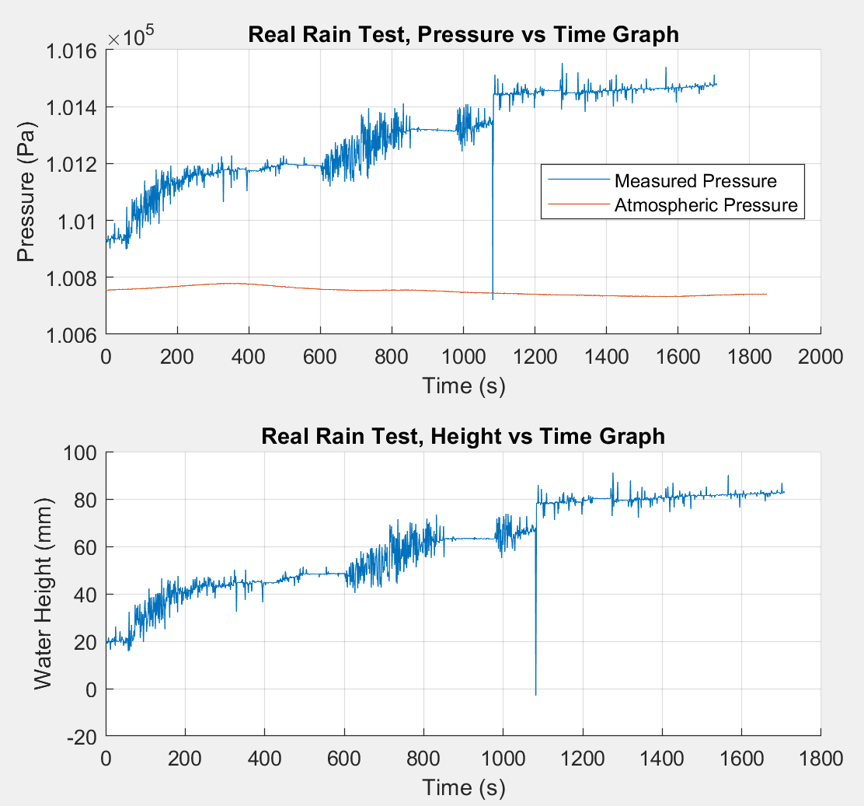
Note. From “A smart IoT urban flood monitoring system using a high-performance pressure sensor with LoRaWAN,” by M. C. L. Te et al., 2024, HighTech and Innovation Journal, 5(4). CC BY.

Secured Flood Monitoring and Forecasting (Arante et al., 2025)
The monitoring and forecasting of floods in the Philippines are important due to the occurrence of heavy rains and typhoon scenarios, which cause the rapid rise of water levels. In this regard, Arante et al. (2025) contextualized their research by highlighting the limitations of the existing flood monitoring systems, which are not effective in the Philippines, and the need to develop a secure IoT infrastructure to transmit data on water levels to aid in the prediction of floods. The authors proposed a neuro-fuzzy LSTM machine learning model to improve the accuracy of flood event prediction, which is a form of smart environmental monitoring system in a water-related disaster scenario.
Figure 15
Neuro-Fuzzy Network for Flood Forecasting
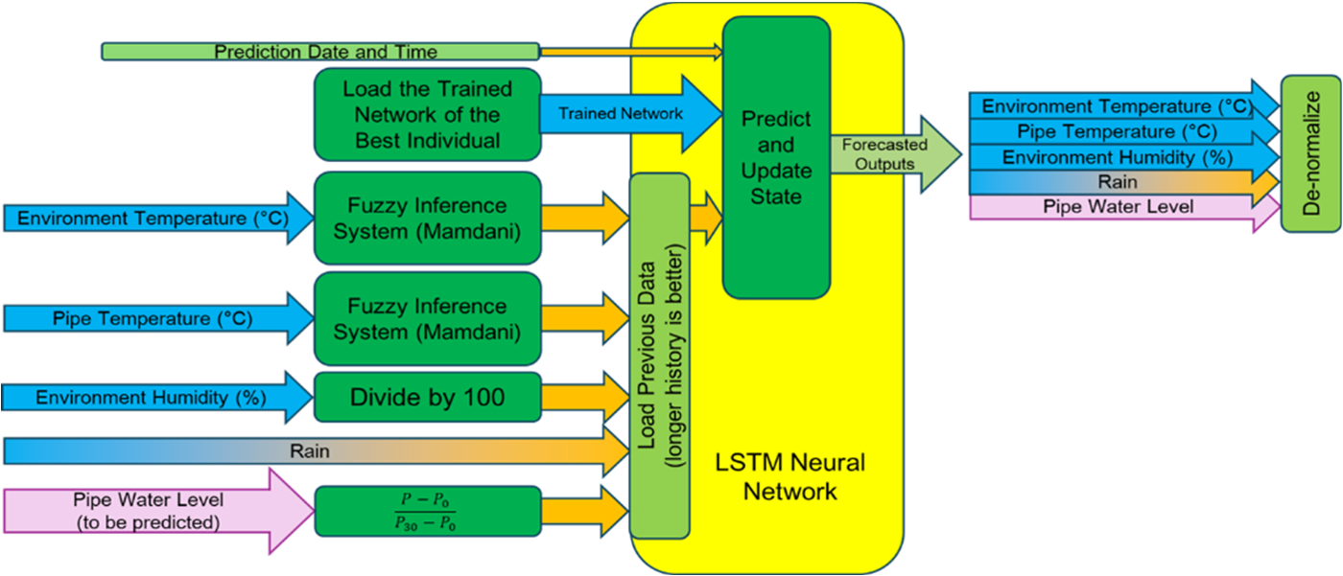
Note. From “Development of a secured IoT-based flood monitoring and forecasting system using genetic-algorithm-based neuro-fuzzy network,” by H. R. C. Arante et al., 2025, Sensors, 25(13), 3885. CC BY.

2.3 Review of Related Patents
Table 1
Table of Related Patents
Patent Title | Author | Adopted Feature | Enhanced Feature
Garbage Detection Method, Related Equipment and Device | Li & Wang (2020) | Image recognition to detect garbage | Enables automatic garbage detection in areas.
Vision garbage classification system based on TensorFlow | Wu et al. (2019) | The AI system classifies garbage usingTensorFlow. | Using similar A system, it improves garbage recognition using deep learning model like YOLOv8
Smart City Waste Collection and Management using IoT | Chordiya et al. (2020) | IoT Sensors monitor garbage compiling systems. | Using a camera for real-time monitoring of garbage
Cleaning Unit Using Deep Learning for Floating Trash Detection | Hyun-dong et al. (2019) | Uses object detection to identify trash | Enhances garbage identification using AI algorithms.
Drainage monitoring apparatus and system | Campbell et al. (2022) | Water level sensors monitor drainage conditions and detect faults. | Detects garbage as a cause of drain blockage in waterways.
System for monitoring water drainage | Den Hartog & Voncken (2017) | Sensors monitor water levels in drain systems. | Detects water blockage and water conditions.
Detection and monitoring of waste disposal using artificial intelligence | Liu et al. (2022) | AI monitors garbage in the environment | Tracks garbage data using automated analysis.
Flood warning system | Torres et al. (2024) | Sensors detect rising water levels. | Alerts user when garbage buildup cause flooding
Method and System for Flood Early Warning in Smart Cities Based on the Internet of Things | Shao et al. (2023) | IoT sensors monitor rainfall and water levels | Garbage detection as an early indicator of flooding risk
Apparatus and Method for Waste Monitoring and Analysis | Balachandran & Talavera (2023) | Sensors and cameras monitor garbage levels in containers. | Automates garbage detection using Computer Vision analysis
Figure 16
Garbage Detection Method, Related Equipment and Device (Li & Wang, 2020)
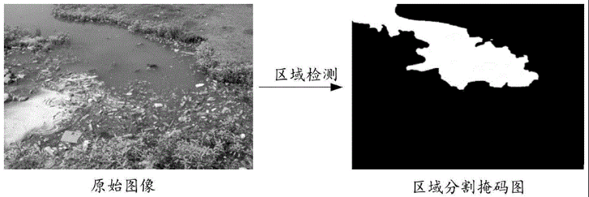
In Figure 16, Chinese researchers have made a garbage detection method using image recognition. The system takes pictures of monitored rivers and processes them to find garbage. This technology can be used in different urban areas such as lakes and parks. It analyzes captured images to think whether garbage objects are visible in the environment. In this patent’s case, it relates to Garbage-Guard because it can use computer vision to detect garbage, similar to the researcher’s proposed system that detects garbage in creeks.
Figure 17
Vision garbage classification system and classification method based on TensorFlow (Wu et al., 2019)
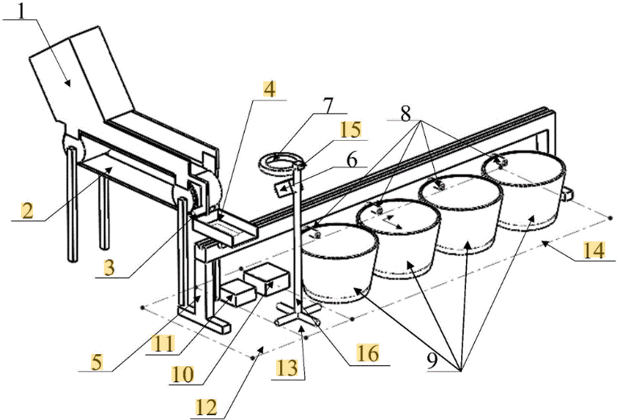
In Figure 17, this patent which uses computer vision, is a Vision Garbage Classification System and Method based on TensorFlow made by Wu et al. (2019). The system uses images of garbage items and puts them into a model trained on garbage images. Methods include data collecting, image processing, and automatic classification of garbage categories. This patent is similar to the researcher’s present study because it also uses the application of computer vision and machine learning techniques but for automated garbage detection.
Figure 18
WCM-Smart City: WASTE COLLECTION AND MANAGEMENT UNDER SMART CITY USING IOT (Chordiya et al., 2020)
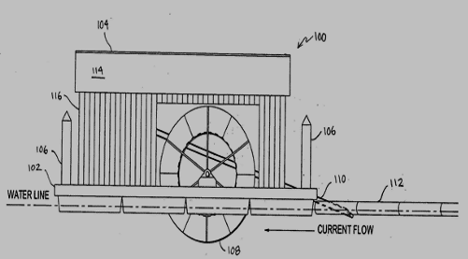
Figure 18 is a patent from Chordiya (2020), describing their study as a waste collection system made for grabbing garbage in rivers and streams. This invention uses a conveyor mechanism that collects waste and transports it into a container. It incorporates monitoring systems with sensors that detect waste levels and can transmit that information to a platform. This patent demonstrates the use of automatic methods for technologies in managing garbage, it is similar to the researcher’s Garbage-Guard system that aims to find garbage in creeks using computer vision technology.
Figure 19
Cleaning Unit Using Deep Learning for Floating Trash Detection (Kim et al., 2019)
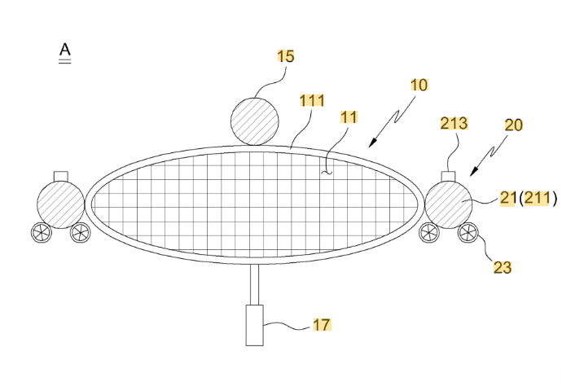
Figure 19 is a similar patent that is related to garbage detection from South Korea. It is a water-surface cleaning unit that uses deep learning technology to detect floating garbage made by Kim et al. (2019). The system integrates a camera module with a deep-learning model which helps in locating garbage on water surfaces. Then, it activates a mechanism that collects the debris from the water. This type of invention shows how relevant it is to the researchers’ study because it is similar to how artificial intelligence is used for garbage detection in water environments.
Figure 20
System for Monitoring Water Drainage. (Den Hartog & Voncken, 2017)
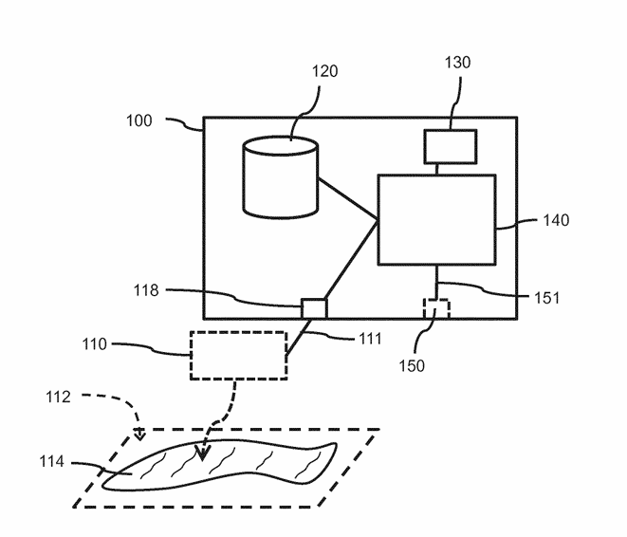
Figure 20, in terms of smart drainage systems, this figure from a patent made by Den Hartog and Voncken (2017) patented a system that is designed to check water drainage environmental sensors. The system collects data from water presence on surfaces and compares it with predicted water drainage conditions based on what happens during rainfall. If the detected water remains longer than usual, the system makes warning signals about potential drainage problems. This type of technology integrates sensors, weather information, and data processing to check drainage conditions. This type of patent is related to Garbage-Guard because both of the systems required to monitor water environments, by detecting garbage being collected in creeks, which may cause drainage issues.
Figure 21
Drainage Monitoring Apparatus and System (Campbell et al., 2022)
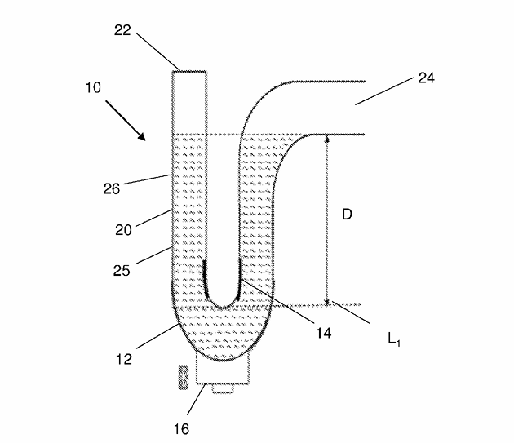
Figure 21 is another patent related to smart drainage monitoring systems, is this patent from Campbell et al. (2022), which showcases a drain monitor apparatus designed to look at water levels within building drainage systems. The invention uses a water trap equipped with a water level sensor that checks the level of water inside the drainage trap. When the water level drops to a specific point, the sensor sends a signal to a system or mobile application that can make audible alerts to inform that there are drainage faults. This technology is relevant to Garbage-Guard since it is similar to how the systems monitor drainage systems. However, instead of detecting water levels, it detects the various amounts of garbage in creeks using computer vision.
Figure 22
Detection and Monitoring of Waste Disposal Using Artificial Intelligence. (Liu et al., 2022)
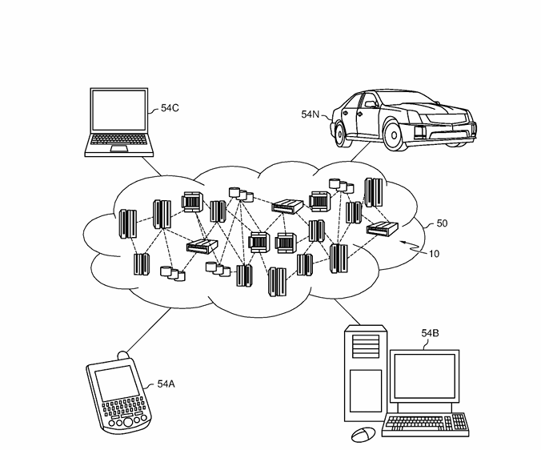
Figure 22 patent by Liu et al. (2022) made an artificial intelligence system for detecting waste in environmental locations, just like natural environments. The system collects images using sensors or cameras and gives them to machine-learning algorithms that check waste objects. Then, the system tracks waste accumulation patterns and finds the location and size of garbage in monitored areas. This patent is similar to Garbage-Guard’s usage of Artificial Intelligence and image analysis to find garbage in different locations.
Figure 23
Flood Warning System (Torres et al., 2024)
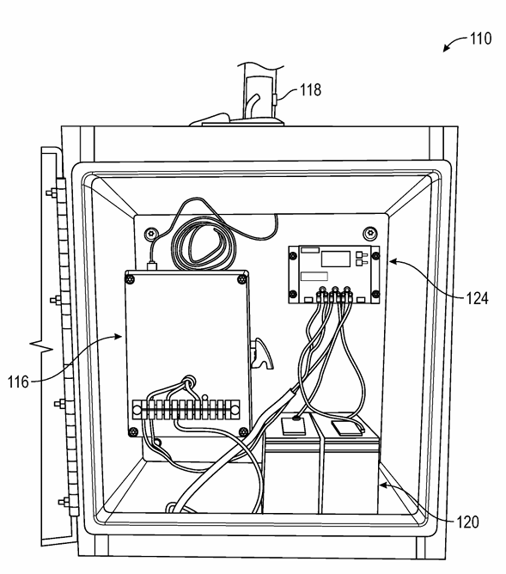
Figure 23 patent by Torres et al. (2024) made a flood warning system to provide early warnings for floods using monitoring systems. It includes multiple of these in monitoring stations near rivers or drainage channels. Each of these are equipped with sensors that monitor water level and rainfall accumulation. That collected data is connected wirelessly to a flood warning station, where it is checked to determine whether the water level exceeds the thresholds. When a flood risk has been shown, the system will make visual alerts that are sent to users through mobile devices. This patent is useful and similar to Garbage-Guard’s system, since warning systems are important in monitoring the environment and can notify when the creeks are filled with garbage.
Figure 24
Method and System for Flood Early Warning in Smart Cities Based on the Internet of Things (Shao et al., 2023)
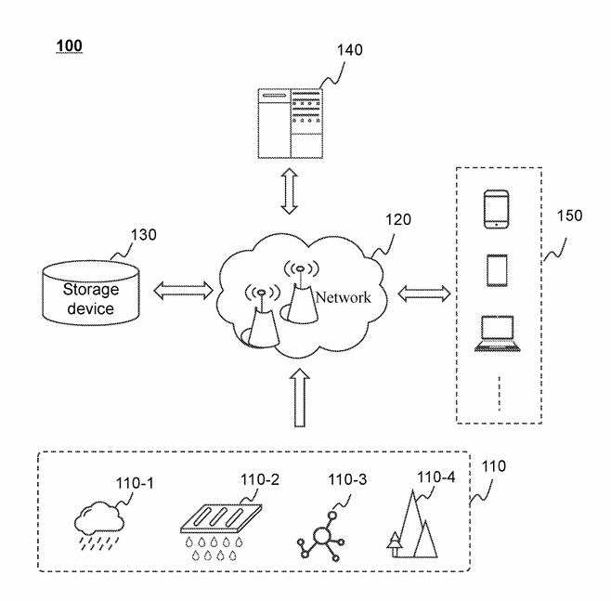
The patent at Figure 24 from Shao et al. (2023), made a smart flood early warning system that has Internet of Things (IoT) with data to detect potential flooding conditions in urban places. This system collects precipitation information from weather stations and combines it with the data from the sensors to estimate water level in specific areas. This invention is similar to Garbage-Guard where they involve environmental monitoring and alerts.
Figure 25
Apparatus and method for waste monitoring and analysis (Balachandran & Talavera, 2023)
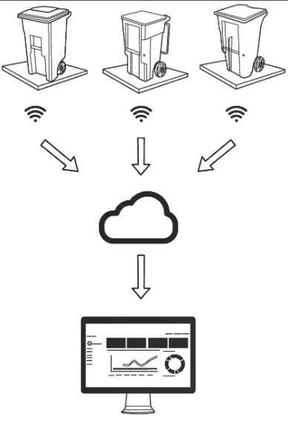
In Figure 25, a patent by Balachandran & Talavera (2023) invented a waste monitoring and analysis system, made for analyzing waste collected in containers. It uses sensors such as load cells and cameras to measure the weight and type of waste material placed inside bins. That data is collected and given to a cloud platform where it can be analyzed. With this information, it can define the pattern of the trash disposals, and make reports about waste generation. This patent is relevant to Garbage-Guard because it shows how sensor based systems can monitor and analyze data in real time. The invention focuses on detecting waste garbage collection in creeks using computer vision technology.

2.4 Synthesis of the Review
The literature reviewed in this chapter converges on four points. First, the volume of plastic reaching the ocean through rivers is large, is concentrated in a small number of waterways, and is worst where collection is weakest. Meijer et al. (2021) place more than a thousand rivers behind eighty per cent of riverine plastic emission, and Ng et al. (2023) and Corpuz (2025) locate Southeast Asia and the Philippines specifically among the places where collection infrastructure does not keep pace. The problem this study addresses is therefore a documented and measured one rather than a local inconvenience.
Second, manual inspection does not scale to it. The studies that quantify waste in waterways rely on survey campaigns, satellite passes or modelled estimates, none of which produce a reading an operator can act on the same afternoon.
Third, convolutional object detection is mature enough to carry the task. Murat and Kiran (2025) and Yaseen (2024) document a decade of accuracy and speed gains across YOLO versions, and Nežerka et al. (2023) show convolutional classification outperforming hand-selected feature extraction on waste fragments specifically. Detection of floating waste is not an open research question.
Fourth, the supporting pieces are established independently. Li et al. (2024) demonstrate a small YOLO variant detecting floating objects on an edge device at thirty-three frames per second. Nunkhaw and Miyamoto (2024) pair detection with tracking so that an item drifting through the frame is counted once. Nunkhaw et al. (2025) carry the same approach into Southeast Asian urban canals and document the gap between laboratory and field performance. Jia et al. (2023) address the shortage of public floating-litter data, and Kataoka et al. (2024) weigh segmentation against bounding-box detection. Narayana et al. (2024), Zeng et al. (2024) and Te et al. (2024) establish that environmental sensing on constrained hardware with real-time alerting is routine practice.
No study reviewed here brings these pieces together in the form this project requires. The waste-detection work classifies images without counting accumulation over time. The accumulation work counts items in containers rather than on moving water. The environmental monitoring work alerts on scalar sensor readings rather than on a visual count. None of the reviewed systems runs a trained detector on an edge device at a creek, restricts counting to an operator-defined area of water, holds one identity per item across frames, smooths the count so that no single frame can raise an alert, and raises a threshold alert on the result. Table 2 sets out that gap against what this study proposes.
Table 2
Proposed Solution Matrix
Limitation in the reviewed literature | Representative source | How Garbage-Guard responds
Waste detection stops at classification, with no accumulation measure over time | Nežerka et al. (2023); Magyar et al. (2023) | The items inside the monitored area are counted, smoothed over fifteen frames and compared with an operator-set threshold, so the output is a sustained accumulation reading rather than a per-frame label
Monitoring of waterways depends on manual survey or satellite passes, so readings are periodic | Meijer et al. (2021); Victoriano et al. (2022) | Continuous processing of a fixed camera feed, with every event logged and timestamped on site
Counting systems assume a contained, static scene | Balachandran and Talavera (2023) | Region filtering confines counting to a traced area of the water, and tracking keeps one steady identity per floating item
Environmental alerting is driven by scalar sensor thresholds rather than visual evidence | Te et al. (2024); Arante et al. (2025) | The alert is raised from a visual count and carries a saved snapshot, so the reading that triggered it can be reviewed
Detection models are reported on curated datasets rather than deployment conditions | Li et al. (2024); Nunkhaw et al. (2025) | The model is reported on a frozen held-out partition and again on a creek-only subset, so field performance is stated separately

III. METHODOLOGY

3.1 Project Design
Figure 26
Garbage-Guard’s System Architecture
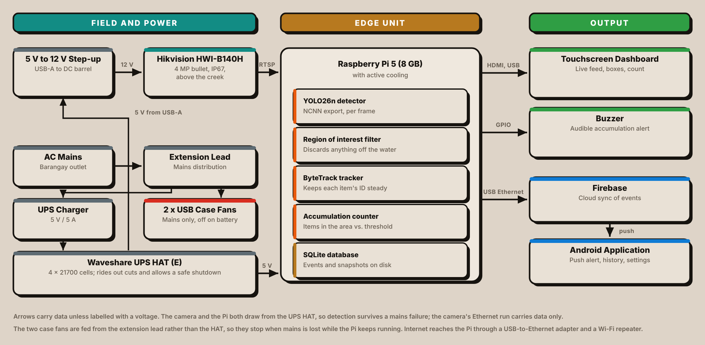
The project design highlights essential components, structure, and processes required to achieve the study's objectives. It includes hardware and software integrations, block and flow diagrams, and the sequential operations necessary for the system's functionality.
The proposed Garbage-Guard prototype should auto-detect floating garbage materials while monitoring a creek. With this, it employed a high-definition CCTV camera wherein real-time videos are being used, then applied the YOLO26 object detection algorithm; thus, able to classify whether the objects floating on the water are bottles, bags, or food containers accurately wherein all these processes are done inside the Raspberry Pi 5 edge computer as seen in Figure 26.
The prototype includes the following components:
- Input: Live video footage of the creek surface recorded by a CCTV camera.
- Processing: A YOLO26n model, exported to NCNN and run on a Raspberry Pi 5, with a region-of-interest filter and ByteTrack tracking, classifies and counts floating solid garbage.
- Storage: Detection and accumulation records are stored in a SQLite database on the unit, with a snapshot for every event, and synchronised to Firebase.
- User Interface: Real-time detections and accumulation alerts are shown on a touchscreen dashboard, sounded on a buzzer and pushed to an Android application.
The system will work in real-time, so it will not only help local authorities with insights to enforce environmental regulations but also minimize severe pollution in local waterways. By providing immediate feedback on garbage accumulation, the system promotes better ecological management and awareness among communities. This proactive approach contributes to creating cleaner waterways, reducing environmental health hazards, and enhancing compliance with proper garbage disposal standards.

3.2 Block Diagram
Figure 27
System Flow of the Waste Detection System
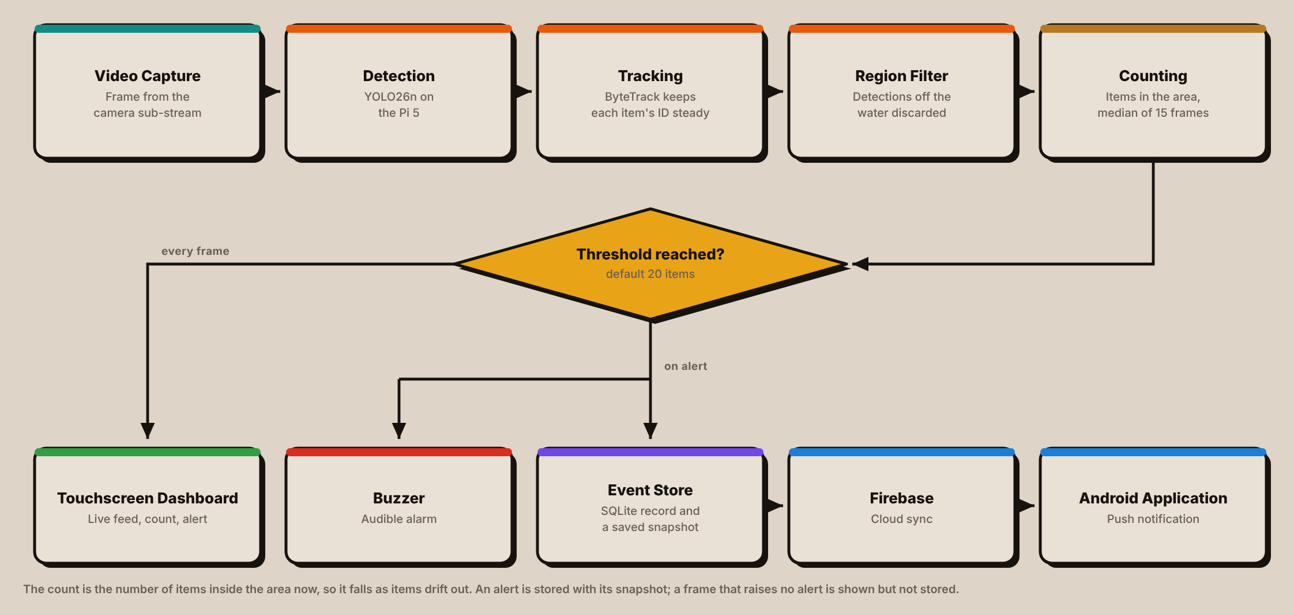
The block diagram in Figure 27 demonstrates how the integration of the YOLO26 algorithm, an edge computing device (Raspberry Pi 5), and a CCTV camera makes real-time garbage detection and data storage more efficient.
After system initialization, the camera captures a live video feed of the targeted water surface. This feed is transmitted to the main processing unit, the Raspberry Pi 5, where the YOLO26 algorithm analyzes the footage in real-time to classify floating solid garbage, track each item so that its identity stays steady, and discard detections outside the monitored water area before counting what remains. The system shows the annotated results in real-time and allows users to view the live dashboard, monitor accumulation alerts, and access data. The main processing unit handles crucial decision-making by triggering an alert when the detected garbage threshold (default 20) is reached. Furthermore, it securely stores relevant information regarding the detected garbage categories, timestamps, and accumulation events in the local database for future examination. Through this seamless integration of hardware (Raspberry Pi 5 with a camera) and software (YOLO26), the system ensures safe data storage while providing efficient garbage identification to help local communities observe and manage environmental hazards.

3.3 Flowchart
Figure 28
Garbage-Guard’s System Flowchart
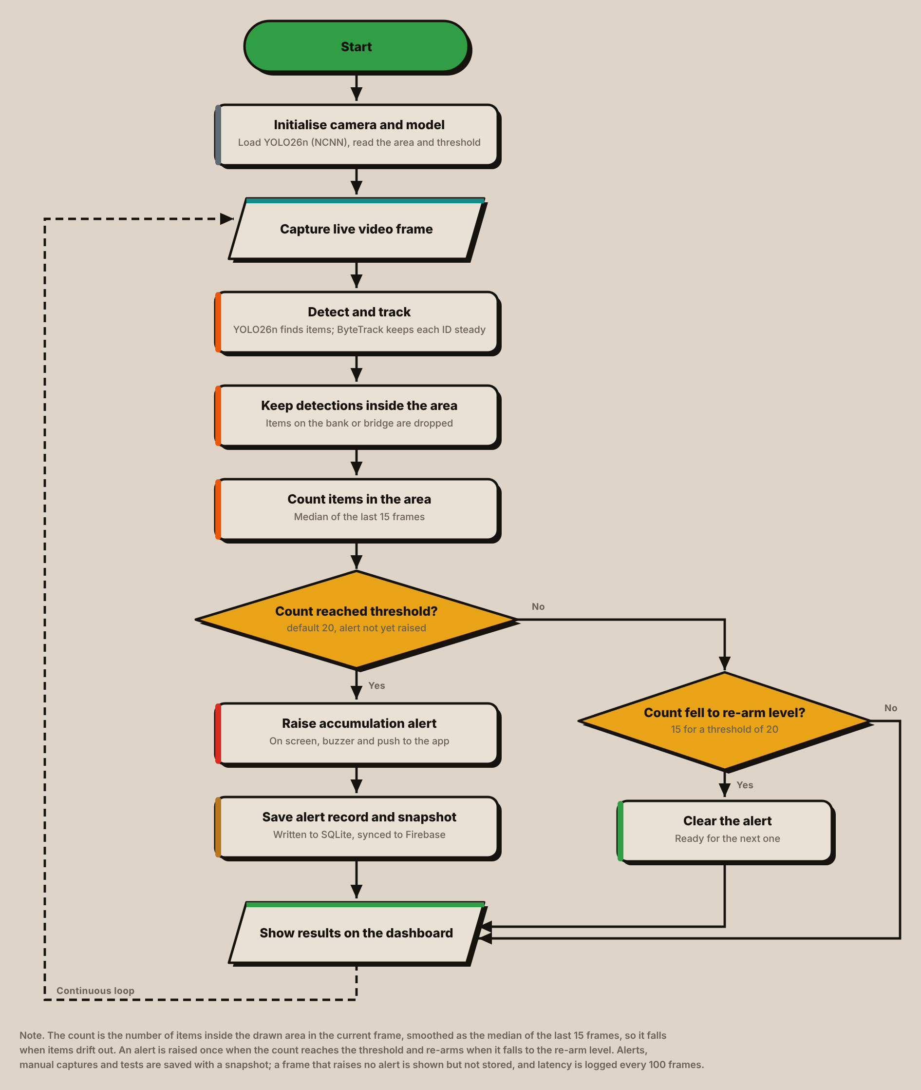
Figure 28 represents the garbage detection and data management process. It starts with powering on, initialising the camera, and loading the model together with the saved monitoring area and threshold. The system then captures a live video frame, runs YOLO26n on it to detect floating garbage, and passes the detections to ByteTrack, which keeps one identity per item so that its box and label stay steady from frame to frame.
Detections outside the region of interest are then discarded, so that objects on the bank or a bridge are never counted. The items that remain inside the region are counted, and the count is smoothed as the median of the last fifteen frames. The count therefore describes how much garbage is present in the area now: it rises as items collect and falls as they drift out.
The first decision point compares the smoothed count with the accumulation threshold, set to a default of 20 items and adjustable from the dashboard. If the threshold is reached and no alert is already active, the system raises the Accumulation Alert on the touchscreen, sounds the buzzer and sends a push notification to the Android application. The alert is written to the SQLite database with its counts, the totals for each class and an annotated snapshot, and synchronised to the cloud.
If the threshold has not been reached, the second decision point checks whether an active alert can be cleared. Once the count has fallen to the re-arm level, fifteen for a threshold of twenty, the alert is cleared and the system is ready to raise the next one. This gap between the two levels stops a pile that hovers around the threshold from raising a fresh alert every few seconds.
In every case the annotated frame and the count are shown on the dashboard and the process returns to capture the next frame. Frames that raise no alert are displayed but not stored; besides alerts, the database keeps manual captures, test alerts, mutes and a summary of the processing latency every hundred frames. The system therefore keeps analysing new video continuously while the record stays small enough for a long deployment.

3.4 Component Materials
This section describes the parts that make up one Garbage-Guard unit, divided into the physical components and the software that runs on them. Each entry states what the component is and what it does in this system, since several were chosen for reasons that are not obvious from the part name alone.

Hardware Components

Raspberry Pi 5 (8 GB)
Figure 29
Raspberry Pi 5 Single-Board Computer
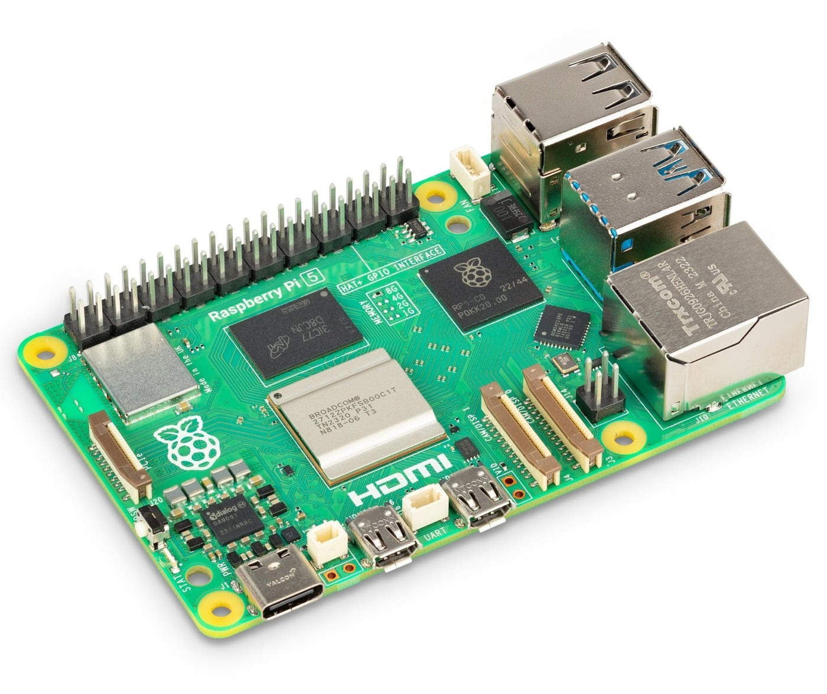
Note. Image from The Pi Hut (n.d.-b).
The Raspberry Pi 5 is a single-board computer built on a quad-core Arm Cortex-A76 processor running at 2.4 GHz, supplied here with 8 GB of memory. It exposes a 40-pin general-purpose input/output header, micro-HDMI outputs, USB 3.0 ports, Gigabit Ethernet and a PCIe interface.
It is the whole of the processing side of Garbage-Guard. It pulls the camera's RTSP stream, runs the detection model, applies the region of interest, keeps the tracker and the accumulation counter, writes to the local database, drives the buzzer on GPIO12, serves the dashboard over HTTP and synchronises events to the cloud. The 8 GB variant was chosen because the model, the tracker and the video decoder hold their working buffers in memory at the same time.

Hikvision HiWatch HWI-B140H Network Camera
Figure 30
Hikvision HiWatch HWI-B140H Bullet Network Camera
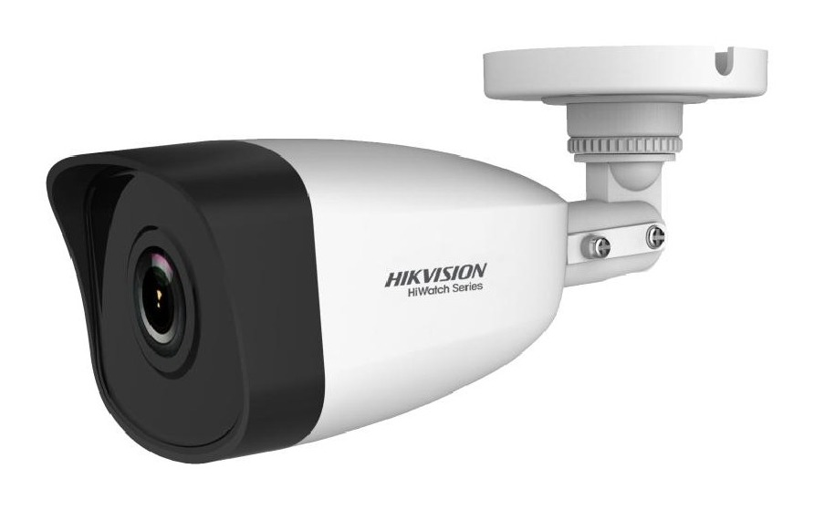
Note. Image from Multi-Line (n.d.).
The HWI-B140H is a 4 MP fixed bullet network camera built on a 1/3 inch progressive scan CMOS sensor with a maximum resolution of 2560 by 1440 at 20 frames per second. It carries a fixed-focus M12 lens at F2.0, an 850 nm infrared illuminator reaching about 30 m and a 120 dB wide dynamic range, and it is rated IP67 with an operating range of minus 30 to 60 degrees Celsius. It accepts either power over Ethernet or 12 V direct current on a 5.5 mm coaxial plug, drawing at most 5 W on the direct current input (Multi-Line, n.d.).
It is mounted above the creek and aimed along the water surface, and it is the only sensor in the system. Everything Garbage-Guard reports is derived from this one feed, which is why the IP67 rating and the wide temperature range matter for an outdoor deployment. Because the region of interest is traced against the camera's exact view, the mounting is fixed first and the region drawn afterwards, never the reverse.
The camera is run on its 12 V input rather than on power over Ethernet, so the Ethernet cable carries data only. Garbage-Guard reads the camera's sub-stream rather than the main stream. The sub-stream is delivered at 640 by 480 or 640 by 360, which is a useful match: the detection model was trained at an image size of 640, so the Pi decodes frames at roughly the size the model expects instead of downscaling a 1440p stream on every frame.

Waveshare UPS HAT (E)
Figure 31
Waveshare UPS HAT (E) with Four Battery Bays
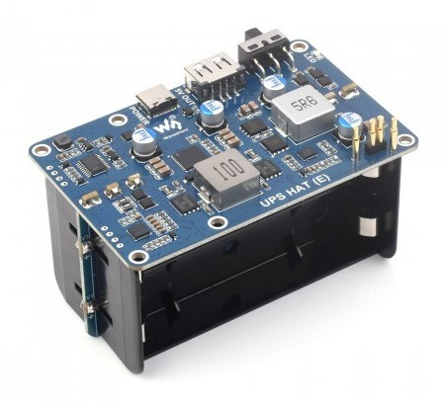
Note. Image from Waveshare (n.d.-b).
The Waveshare UPS HAT (E) is an uninterruptible power supply board carrying four 21700 lithium-ion cells. It mounts beneath the Raspberry Pi rather than on top of it, connecting through high-current pogo pins that press against the underside of the board, and it delivers 5 V at up to 6 A. It passes mains power through while charging, takes over when that supply fails, and reports its state over I2C, exposing voltage, current, power, the four individual cell voltages and the charger input. It also provides a USB-A output.
The pogo-pin connection is worth naming, because it leaves the Pi's 40-pin header completely free (Waveshare, n.d.-b). A conventional supply board sitting on that header would have taken the pins the buzzer needs, so the choice of this particular board is what allows the audible alert to exist without a pass-through or a ribbon extension.
In Garbage-Guard it is what makes an unattended deployment safe. The power module reads the charge level over I2C and begins a five-minute countdown toward a clean shutdown when the battery runs low, with a floor at five per cent and a grace period after boot, so the Pi is never cut off mid-write.

5 V to 12 V USB-A to DC Barrel Step-up Cable
A step-up, or boost, converter raises a lower input voltage to a higher one. The part used here is the cable form of that circuit, with a USB-A plug at one end, the converter moulded into the lead, and a 5.5 mm barrel plug at the other. It is rated 12 V at 1 A.
Its 5 V comes from the USB-A output on the UPS HAT rather than from a separate adapter, so the camera is powered through the same battery-backed supply as the processor. A mains failure therefore does not blind the system: the camera and the Pi stay up together or go down together. The rating also covers the load with room to spare, since the camera draws at most 0.42 A at 12 V, which is well under half the cable's rating. That margin matters because a converter run near its limit is a common cause of intermittent faults in field equipment, and an intermittent camera would present as a detection problem rather than a power one.

USB-to-Ethernet Adapter and Wi-Fi Repeater
The Raspberry Pi 5’s own Ethernet port is given over to the camera, on a direct link with fixed addresses at both ends, so the unit reaches the internet through a second, USB-to-Ethernet adapter plugged into one of the Pi’s USB ports. That adapter is cabled to the LAN port of a 2.4 GHz Wi-Fi repeater set to repeater mode, which joins the site’s wireless network and passes the connection through to the Pi.
The repeater was adopted after testing showed that the Pi’s built-in wireless adapter could not complete a connection to any network, an open one included. Routing through it has a practical benefit beyond that: to move the unit to another site, only the repeater is pointed at the new network, or at a phone hotspot, from its own setup page, and nothing on the Pi changes. The camera link and the internet link stay on separate ports, so a fault on one does not interrupt the other.

7-inch IPS Touchscreen
The display is a 7 inch IPS panel at 1024 by 600. It takes video on HDMI and reports touch over USB. The panel type is worth naming because the screen is read at an angle as often as straight on when the unit is mounted at the waterside, and an IPS panel holds its colour and contrast off-axis where a cheaper panel would not.
It is the operator's only local interface. The dashboard runs full screen on it, and the region of interest is drawn by tapping points directly on the video, so the touch layer is not a convenience but the means of configuring the system on site. The screen saver turns the HDMI output off after a timer, sooner on battery, and the touch device is read directly so that a tap wakes the screen while the output is off.

Raspberry Pi Active Cooler
Figure 32
Raspberry Pi Active Cooler Fitted to a Raspberry Pi 5
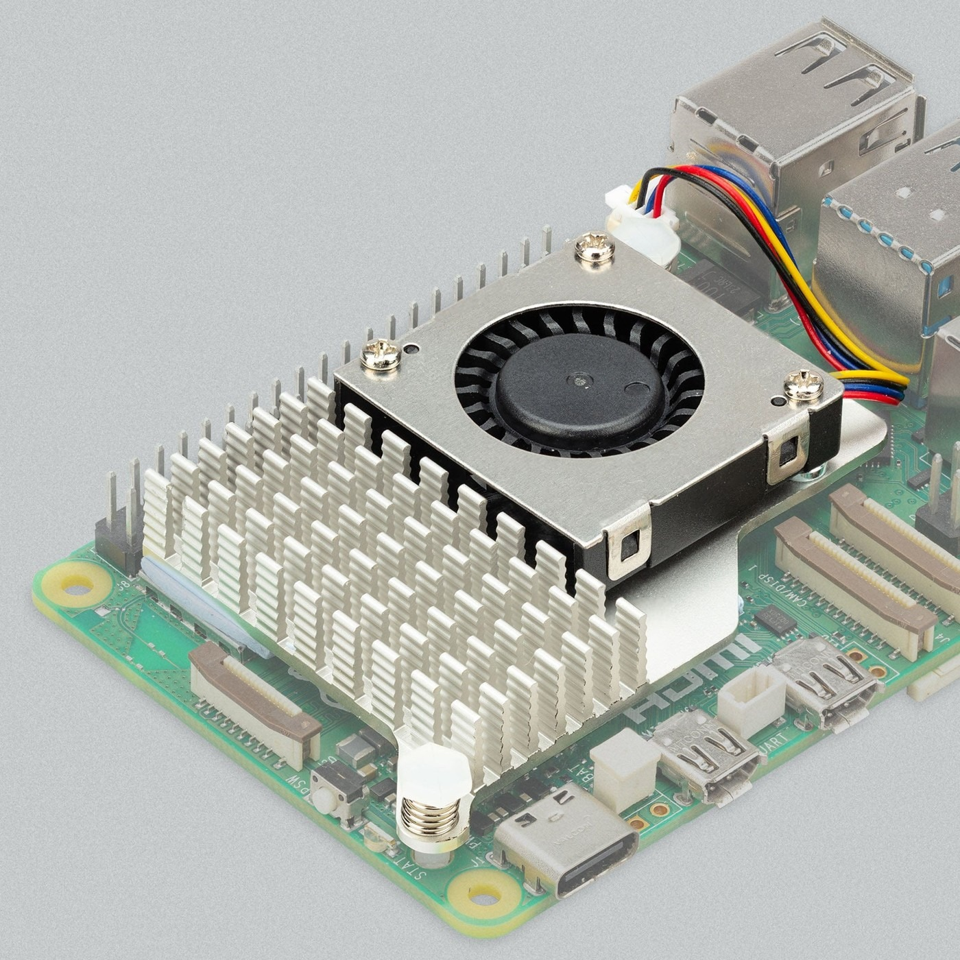
Note. Image from The Pi Hut (n.d.-a).
The official Raspberry Pi Active Cooler is a combined heatsink and fan that clips onto the Pi 5's mounting points and is driven from the board's dedicated fan header, which lets the firmware vary its speed with the processor temperature.
Sustained inference is the reason it is fitted rather than treated as an optional extra. Running detection on every frame holds the processor near its thermal limit indefinitely, and a Pi 5 that reaches that limit reduces its clock speed, which would appear as rising latency and a falling frame rate rather than as an obvious fault. Active cooling keeps the measured latency representative of the hardware rather than of its thermal state.

SanDisk 64 GB High Endurance microSD Card
Figure 33
SanDisk High Endurance 64 GB microSD Card
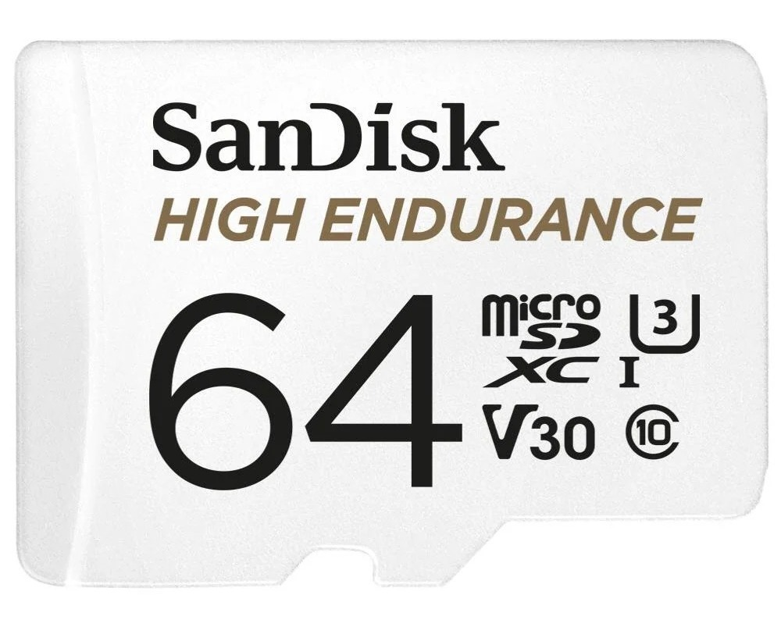
Note. Image from JB Hi-Fi (n.d.).
The card is a SanDisk High Endurance model. That line is built for devices which write continuously, such as dashboard cameras and surveillance recorders, rather than for the occasional large transfers a standard card is rated for.
The card carries Raspberry Pi OS and nothing else; the detection data lives on the solid-state drive described below. Its workload is therefore the operating system's own, namely journal writes, logs and the housekeeping of a machine that is never switched off. That is lighter than the detection workload but still continuous, and it runs for the whole of a field deployment, which is why an endurance-rated card is the sensible choice for a system left running unattended.

KingSpec 256 GB M.2 Solid-State Drive with Waveshare PCIe Adapter
Figure 34
KingSpec M.2 2242 NVMe Solid-State Drive
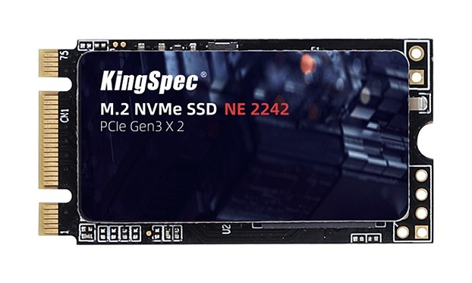
Note. Image from KingSpec (n.d.).
Figure 35
Waveshare PCIe to 2-Channel M.2 Adapter
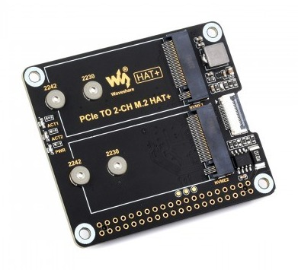
Note. Image from Waveshare (n.d.-a).
The solid-state drive is a KingSpec 256 GB module in the 2242 form factor, carried on a Waveshare PCIe to two-channel M.2 adapter that connects to the Raspberry Pi 5's PCIe interface. Being a two-channel adapter it takes a second module alongside the first, so storage can be extended for a longer deployment without changing the board or the mounting.
The drive carries the project folder, and with it the exported model, the database and the snapshot store, while the operating system stays on the microSD card. That separation is the point of the arrangement. Garbage-Guard writes a snapshot for every recorded event and appends to the database continuously, which is a sustained small-write workload of exactly the kind that wears flash storage. Putting it on the drive means the heavy writing happens on the device best able to absorb it, and that a storage failure there would not take the operating system with it.

Passive Buzzer Module
A passive buzzer has no oscillator of its own, so it makes no sound unless the controller drives it with a changing signal. That is a limitation on paper and an advantage in practice, because the pitch is then under software control and one device can produce several distinguishable sounds.
It is wired with its supply to physical pin 17 at 3.3 V, its signal line to physical pin 32 at GPIO12, and ground to physical pin 34. The buzzer module gives each event its own sound and raises a repeating alarm when the accumulation threshold is crossed. It drives the pin by software pulse-width modulation by default and switches to hardware modulation when the pin has been configured for it, which is louder and steadier. Quiet hours and a mute panel on the dashboard suppress it when a reading is being taken by hand.

Metal Waterproof Junction Box, Extension Lead and Case Fans
The electronics are housed in a metal waterproof junction box of the type sold for closed-circuit television installations, measuring 25 x 30 x 15 centimeters, with openings cut for the mains extension lead and the camera cabling and sealed with a rubberized water sealant. Two USB fans are mounted on each side. The boards are stacked in a fixed order: the UPS HAT at the bottom, the Raspberry Pi above it with its active cooler, and the PCIe adapter carrying the solid-state drive on top.
Mains reaches the unit through the extension lead, which serves as the distribution point inside the enclosure. The UPS charger and the two case fans are plugged into it. The split matters and should be stated rather than glossed: the UPS, and therefore the Pi, its cooler and the camera, continue through a mains failure, while the case fans do not, because they are fed from the lead directly. On battery the enclosure fans stop while the processor carries on running detection inside a closed box. That is a deliberate trade, since running the fans from the battery would shorten the time the system can keep detecting.
The enclosure is not itself left in the weather. The unit is sited under shelter and only the camera is mounted outdoors, wired back to the box. That division is what makes the arrangement sound: the camera is the part exposed to rain and sun and it is the part carrying a manufacturer's IP67 rating, while the enclosure holds the parts that have no such rating and is kept out of the weather accordingly.

Software Components

Raspberry Pi OS and the Python Environment

The unit runs Raspberry Pi OS with the detection program in a virtual environment kept separate from the system packages. An installer registers the launcher so that switching the Pi on is enough to bring the system up: it checks the camera, raises the network profile if needed, activates the environment, opens the dashboard full screen and starts detection. If no network is in range it shows a wireless setup screen first.

YOLO26n Detection Model, Exported to NCNN

The detector is a YOLO26n convolutional neural network, trained on the custom dataset and exported to NCNN, an inference framework built for mobile and embedded processors. NCNN is used rather than the original weights because it is markedly faster on the Pi's Arm processor.
The model classifies three categories, in order: bottle, bag and food container. Its scores on the frozen test partition are a precision of 0.852, a recall of 0.685 and a mAP@0.5 of 0.745, and on the creek-only subset a precision of 0.742, a recall of 0.534 and a mAP@0.5 of 0.593. These are the figures Chapter IV reports against.

ByteTrack Multi-Object Tracker
ByteTrack is a tracking-by-detection algorithm that associates detections across consecutive frames, including low-confidence ones that a simpler tracker discards, and assigns each object a stable identity for as long as it stays in view.
It keeps the live view readable and the count steady. Without it, each item’s box would be drawn afresh in every frame and could flicker between classes or drop out for a frame. Each box on the dashboard carries a small identity number, starting at 1, and the number is released once its object has been missing for about thirty frames.

Region of Interest and Accumulation Counter

The region of interest is a polygon traced on the video by the operator, stored on disk and reloaded at start-up. Detections whose position falls outside it are discarded before counting, which is what prevents the bank and the bridge wall from entering the tally.
The counter takes the number of items inside that region in each frame and smooths it as the median of the last fifteen frames, so a single missed or false detection does not move it. When the smoothed count reaches the threshold, twenty by default and adjustable from the Settings tab, an alert is raised once; it re-arms only after the count has fallen to fifteen, so a pile hovering around the threshold does not raise repeated alerts. Because the model’s recall is about 0.70, a displayed count of twenty does not mean exactly twenty items are present, so the threshold is calibrated on site rather than assumed.

SQLite Database and Snapshot Store

Accumulation alerts, brief spikes that reached the threshold without being sustained, mutes, manual captures and test alerts are written to a local SQLite database, each alert and capture with a snapshot showing the boxes, the monitored area and the count stamped onto the frame. A summary of the processing latency is written every hundred frames. Frames that raise no alert are shown on the dashboard but not stored, which keeps the database small over a long deployment.
Keeping the record locally means the system loses nothing when the network drops, and the saved snapshot means any logged reading can be checked afterwards against the image that produced it.

Touchscreen Dashboard
The dashboard is a single HTML file served over HTTP from the Pi by Python's built-in web server, with no build step and no external dependencies. It has three tabs: Monitor, History and Settings.
Monitor carries the live feed with bounding boxes, the running count, the frame rate and the mute panel, and it is where the region of interest is drawn. History lists recorded events with their snapshots and a filter bar. Settings holds the detection threshold, the alert preferences, the screen saver and the power options.

Cloud Synchronisation

Firebase is used as the link between the unit and the phone, carrying events and system state upward under a set of access rules.
It exists so that an operator does not have to be standing at the creek to know the threshold has been crossed. The Pi remains the system of record and the cloud carries a copy.

Android Application

The Android application is written in Kotlin with Jetpack Compose. It receives push alerts, shows the detection history and allows the detection settings to be changed remotely.
It is the second half of the alerting path. The buzzer and the on-screen warning serve whoever is present; the application serves whoever is not.

3.5 Project Development
Figure 36
V-Model SDLC Model
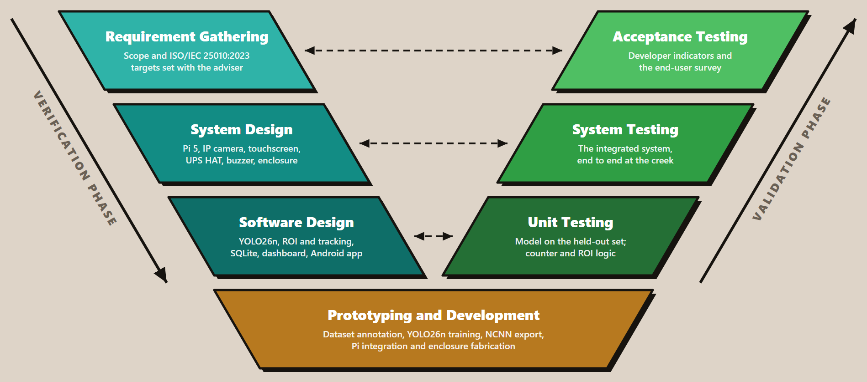
Note. Adapted from “What is the V-model in software development?” by Oppermann & Whitfield, 2025, Built In (https://builtin.com/software-engineering-perspectives/v-model).
The researchers adapted the traditional V-Model Software Development Life Cycle for the Garbage-Guard System to better suit the hardware and software integration requirements for the prototype. Figure 36 shows the relationship for each phase, ensuring that they are systemically combined throughout the development process. This adapted V-Model has three phases which are Verification, Prototyping & Development, and Validation. This approach ensures a smooth and strict relationship between the design parameters and testing protocols so each design and test phase can be conducted in parallel to each other.
Figure 37 shows how the detection model itself was produced, which the V-Model places inside the prototyping and development phase. The sequence runs from collection at the creek through annotation, the dataset split, training, evaluation on the held-out partition, export to NCNN and deployment on the Raspberry Pi. The dashed return path is not decorative: weak per-class results sent the work back for further collection and annotation, and the model deployed at the creek, v7, came out of the eighth training run rather than the first.
Figure 37
Model Training and Deployment Pipeline
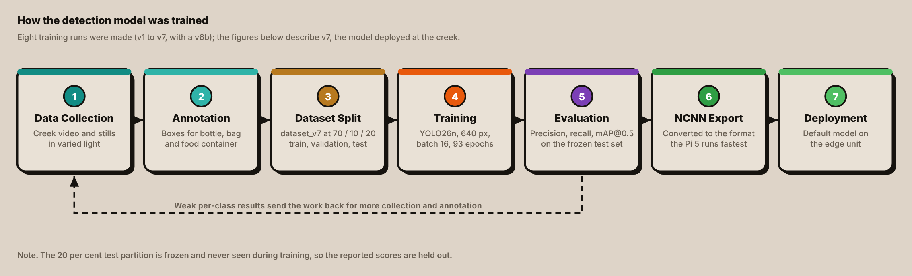

Phase 1: Verification (Left Side of the V)
This phase defines the exact parameters the system must meet, and also the design of hardware and software to achieve those goals.

Requirement Gathering
The researchers consulted with researchers’ thesis advisor Prof. Jonel R. Macalisang, to make the scope and title of the Garbage-Guard project. During the phase, the requirements were specifically defined. Under the guidance of researchers’ Technical Research Advisor, Prof. Ma. Ian De Los Trinos, the criteria for the acceptance testing were accepted using the ISO/IEC 25010:2023 standard. The assessment covered three software quality characteristics:
- Functional Suitability: To evaluate the accuracy of the garbage detection and of the accumulation count.
- Performance Efficiency: Evaluate the speed and time of detection.
- Usability: To evaluate how readable and operable the dashboard and the alerts are for the people who will use them.

System Design
In this stage, the researchers planned the physical system architecture and the required components to show portability, and continuous operation. The researchers designed the layout of the hardware, utilizing these components:
- Camera (Hikvision HiWatch HWI-B140H) - The sensor for real-time computer vision capture.
- Raspberry Pi 5 (8 GB) with the official Active Cooler - The core processor that executes the computer vision algorithm.
- 7-inch IPS touchscreen - The display interface that shows the real-time video feed and the log history of detected garbage, and is used to draw the monitored area.
- Storage - A 64 GB High Endurance microSD card holds the operating system, and a 256 GB M.2 solid-state drive on a Waveshare PCIe adapter holds the model, the database and the snapshots.
- Waveshare UPS HAT (E) with four 21700 cells - Provides an uninterruptible power supply with a safe shutdown on power loss; its USB-A output also feeds the camera through a 5 V to 12 V step-up cable.
- Extension lead, UPS charger and two USB case fans - Mains power reaches the UPS charger and the case fans through the lead; the fans stop when mains is lost.
- USB-to-Ethernet adapter and Wi-Fi repeater - Carry the cloud link to the site’s wireless network, leaving the Pi’s own Ethernet port for the camera.
- Passive buzzer module - Gives an audible accumulation alert from a GPIO pin.
- Metal waterproof junction box - Houses the electronics under shelter, with openings sealed with a water sealant; only the camera is mounted outdoors.

Software Design
The software architecture was planned across three distinct layers:
- AI / Computer Vision: A YOLO26n convolutional neural network, exported to NCNN, with a region-of-interest filter and ByteTrack tracking, for real-time detection and counting.
- Front-End (UI/UX): The touchscreen dashboard at the unit, and an Android application for remote alerts, history and settings.
- Back-End (Database): A lightweight local SQLite database that logs detections, counts and snapshots, synchronized to Firebase.
The architecture ensures modularity and separation of concerns between detection, processing, and visualization components.

Phase 2: Prototyping and Development (Vertex of the V)
Serves as the vertex of the adapted V-Model, where the project moves from theoretical designs to physical fabrication. Development began with building and annotating a custom dataset, training the YOLO26n model on a workstation GPU over several iterations, and exporting it to NCNN. The model was then deployed on the Raspberry Pi 5 to check compatibility and functionality, and the tracker, the region filter, the counter, the dashboard and the Android application were built around it.
The prototype was fabricated for portability. The Raspberry Pi, the UPS, the storage and the step-up cable are secured inside a metal waterproof junction box, with openings cut for the cables and sealed with a water sealant, and two USB case fans mounted on the side. The unit is sited under shelter, and only the camera is mounted outdoors above the water, wired back to the box.

Testing Parameters and Scale of Measurement
Table 3
ISO/IEC 25010:2023-based Metrics Descriptions and Scale of Measurements for Garbage-Guard
Objectives |  | Definitions | Metrics | Description | Scale
1. | Functional Suitability  (Classification) | The ability of the YOLO26n model to correctly identify and classify solid garbage (bottles, bags, food containers). | Percentage average (%) of correct garbage recognition against total samples tested. | Excellent | 95% - 100%
 |  |  |  | Very Good | 90% - 94.99%
 |  |  |  | Good | 80% - 89.99%
 |  |  |  | Fair | 70% - 79.99%
 |  |  |  | Poor | Below 70%
2. | Functional Suitability  (Accumulation Detection) | The system’s ability to accurately track the item count and successfully trigger an “Accumulation Alert” once the threshold (default 20 items) is reached. | Percentage average (%) of successful alert triggers out of total simulated accumulation test cases. | Excellent | 95% - 100%
 |  |  |  | Very Good | 90% - 94.99%
 |  |  |  | Good | 80% - 89.99%
 |  |  |  | Fair | 70% - 79.99%
 |  |  |  | Poor | Below 70%
3. | Performance Efficiency | The inference time and processing latency of Raspberry Pi 5 to draw bounding boxes on the live camera feed on each floating garbage. | Average inference time (in seconds) during real-time monitoring. | Excellent | Below 0.5s
 |  |  |  | Very Good | 0.51s - 1.5s
 |  |  |  | Good | 1.51s - 3.0s
 |  |  |  | Fair | 3.1s - 5.0s
 |  |  |  | Poor | Above 5.0s
Table 3 shows and defines the metrics that will be used to grade each objective of the Garbage-Guard system based on the ISO/IEC 25010:2023 software quality standards.
(1) The first objective focuses on Functional Suitability (Classification), specifically the accurate measurement of identifying and classifying floating solid garbage such as garbage bottles, garbage bags, and or food containers using the YOLO26n computer vision model. The computations used to determine the accuracy of the garbage classification utilizing variables from the confusion matrix, where the variables are True Positive (TP), True Negative (TN), False Negative (FN), and False Positive (FP) the formulas are listed below:
Precision$= \frac{TP}{TP+FP}$ , Recall$= \frac{TP}{TP+FN}$ , Accuracy$= \frac{TP + TN}{Total Objects} × 100$
(2) The second objective defines an additional layer of Functional Suitability regarding the system’s Accumulation Detection capability. To mathematically and systematically determine if a creek is polluted, the system tracks the item count and is programmed to trigger an "Accumulation Alert" once a predefined threshold, set to a default of 20 detected garbage items is reached. The parameter is measured by taking the percentage average of successful alert triggers out of the total simulated accumulation test cases conducted by the researchers, utilizing the formula below:
Success Rate$= \frac{Number of Successful Alerts }{Total Number of Trials }$ $× 100$
(3) Lastly, the third objective, Performance Efficiency measures the real-time responsiveness of Raspberry Pi 5. This metric evaluates the inference time and processing latency of the Raspberry Pi 5 to successfully process a live camera feed request and draw bounding boxes on each floating garbage without severe hardware degradation. To ensure an objective evaluation, the system is programmed to automatically log the latency of each frame by subtracting the frame capture timestamp (Start Time) from the detection completion timestamp (End Time). The final parameter is measured by using the averaging method to calculate the mean inference time (in seconds) across a standardized test duration, using the formula:
Average Latency$= \frac{∑ ( T_{End} -T_{Start} )}{Total Frames}$

Phase 3: Validation (Right Side of the V)
This phase moves upward of the V-Model, directly testing the design established in the first phase so that it ensures all mathematical and functional conditions are met.

Unit Testing
The unit testing phase is the first testing stage on the right side of the V-Model. It evaluates the software and hardware components of the system in a controlled environment. Based on the project’s scope and objectives, this will involve isolating the YOLO26 algorithm, the accumulation counter logic, and latency logging mechanism on the Raspberry Pi 5 to ensure they will function correctly before the full integration happens.

1. Classification Evaluation
To verify its software components, particularly the object detection algorithm, the frozen held-out test partition is used. The model is mathematically validated using a Confusion Matrix that consists of True Positives (TP), False Positives (FP), True Negatives (TN), False Negatives (FN). Evaluation of the AI Model’s performance is computed based on the following core statistical formulas:
- Precision: Measures the model’s ability to avoid False Positives. It basically measures how many of the items the YOLO26 model identified as garbage were actually garbage.
Precision$= \frac{TP}{TP+FP}$
- Recall: Measures the model’s ability to detect all the actual garbage that is present. It recalls how many of the actual garbage items present in the water were successfully captured by the YOLO26 model. In short, the model’s ability to avoid False Negatives
Recall$= \frac{TP}{TP+FN}$
- Accuracy: The overall correctness of predictions, the ratio of correct predictions to the total number of cases examined. For object detection it is reported for completeness, and mean average precision at an overlap threshold of 0.5 (mAP@0.5) is reported alongside precision and recall, since it is the standard detection measure. The model must reach a precision of at least 80%.
Accuracy$= \frac{TP + TN}{Total Objects} × 100$

2. Accumulation Detection Evaluation (Counter Logic)
To mathematically determine if the system correctly tracks item counts and triggers the “Accumulation Alert” at the 20-item threshold, simulated accumulation test cases are conducted.
Success Rate: Measures the percentage of successful alert triggers out of the total number of simulated trials.
Success Rate$= \frac{Number of Successful Alerts }{Total Number of Trials }$ $× 100$

3. Performance Efficiency Evaluation
Measures real-time responsiveness of the Raspberry Pi 5, the system automatically checks the latency of each frame.
Average Latency: Evaluates the mean inference time (in seconds) across a test duration to ensure that there is no severe hardware degradation. It is calculated by subtracting the frame capture timestamp (Start Time) from the detection completion timestamp (End time).
Average Latency$= \frac{∑ ( T_{End} -T_{Start} )}{Total Frames}$
Table 4
Unit Testing Cases for Controlled Environment Evaluation
Test Case ID | Objective | Procedure | Expected Result | Actual Result | Successful Trials (out of 10)
TC_UNIT_01 | Evaluate Classification Precision, Recall and mAP@0.5 | Run the trained model over the frozen held-out test partition, which is the 20 per cent of the annotated dataset never seen during training, and record per-class and overall results. | The model reaches a precision of at least 0.80, with recall and mAP@0.5 reported alongside it for each of the three classes.
TC_UNIT_02 | Validated Accumulation Counter Logic | Programmatically simulate the continuous detection of floating garbage items, incrementing up to the default threshold | The system triggers the automated “Accumulation Alert” once when the smoothed count reaches the 20-item threshold, and does not raise it again until the count has fallen to the re-arm level of 15.
TC_UNIT_03 | Verify the Performance Efficiency Logging | Run sample video frames through Raspberry Pi 5 to execute the latency tracking script. | The system calculates latency successfully by subtracting the start time from end time without hardware crashing.

System Testing
Once the units are verified, System Testing is conducted. This phase tests the fully integrated system, consisting of the Raspberry Pi 5, the camera, the YOLO26n model, the region filter, the tracker, the database, the touchscreen dashboard, the Android application and the alerting logic. The prototype is deployed at a local creek or barangay site for real-world environmental monitoring. Beyond the model itself, it checks that the system can handle real-time video feeds, tracks only visible floating surface items (excluding sunken or heavily obscured garbage), counts the items present in the monitored area, records every alert, delivers the alert to the user, and maintains efficiency in processing under continuous load.
Table 5
System Testing Cases for Real-World Environmental Conditions
Test Case ID | Objective | Procedure | Expected Result | Actual Result | Successful Trials (out of 10)
TC_SYS_01 | Real-World Object Detection. | Deploy the setup beside the waterways/creek and stream the live footage onto the Raspberry Pi 5 for real-time analysis | Bounding boxes are accurately drawn over visible floating bottles, bags, and food containers, ignoring sunken garbage or organic debris
TC_SYS_02 | Real-time Accumulation Alert | Allow the system to continuously monitor the creek until 20 valid targeted garbage items accumulate on the water surface. | Successfully recognizes the threshold breach and triggers the automated accumulation alert in a live setting.
TC_SYS_03 | Real-time Processing Latency | Monitor the edge computing hardware’s responsiveness while processing the live video feed for a standardized test duration. | The average inference latency per frame is logged automatically and remains stable without causing the system to crash or overheat.
TC_SYS_04 | System Flow (End to End) | Walk the flowchart in one run: switch the unit on, confirm the camera feed appears, place test items in the monitored water area, watch the count rise, cross the threshold, and observe the alert and the saved record. | Each step of Figure 28 happens in order: camera on, detection and tracking, counting inside the region, threshold alert, alert record saved, and the result shown on the dashboard and the application.
TC_SYS_05 | Live Dashboard | Open the dashboard on the touchscreen while detection runs. | The live feed with bounding boxes, class labels, the running count and the frame rate is shown and updates continuously.
TC_SYS_06 | Region of Interest | Draw the monitored area on the water, then place the same test item inside it and outside it. | The item inside the area is counted and the item outside it is ignored.
TC_SYS_07 | Stable Tracking and Count | Let one item drift into the monitored area and out of it again. | The item keeps a single identity number while in view, adds one to the count while it is inside the area, and drops off the count after it leaves.
TC_SYS_08 | Event Storage | Raise an accumulation alert, then take a manual capture, then open the History tab. | Both records appear with their time, counts and a saved snapshot, read back from the database.
TC_SYS_09 | Alert Delivery | Raise an accumulation alert while the Android application is connected. | The alert appears on the dashboard, the buzzer sounds, and a push notification reaches the application.
TC_SYS_10 | Threshold Setting | Change the accumulation threshold in the Settings tab, then repeat the count. | The new threshold takes effect and the alert is raised at the new value.

Acceptance Testing
This testing phase corresponds to the requirement gathering phase of the adapted V-Model. This stage involves presenting the working prototype through a live demonstration in the field to ensure it satisfies the study’s initial objectives.
The prototype will be left running at the creek for one week, and for no fewer than four to five days. The researchers keep an uptime log recording how many days and hours the system stayed running without a crash or overheating, together with the threshold calibration carried out on site. This log is the evidence for the Performance Efficiency indicators, and the end users answer the usability survey after using the system during this deployment.
To ensure an accurate evaluation and establish the clear testing boundaries, this phase will be divided into two distinct testing perspectives: The developer Side (Internal Acceptance) and the end-user side (External Acceptance).

Developer Side Acceptance Testing
The developer side boundary restricts the evaluation purely to the technical performance, hardware stability and algorithmic accuracy of the Garbage-Guard system. The evaluation is conducted strictly by the researchers based on the ISO/IEC 25010:2023 quality standards identified in the study’s scope. During the live demonstration, the researchers will observe the system’s performance to check if the prototype meets the required percentage averages and latency metrics.
Table 6
Acceptance Testing Evaluation Test Cases
Test Case ID | Objective | Procedure | Expected Result | Actual Result | Successful Trials (out of 10)
TC_ACC_01 | Functional Suitability (Classification) | Conduct a live field demonstration to evaluate the percentage average of correct garbage recognition against total samples. | The system achieves a target of “Good” (80%) or better in successfully classifying the 3 target garbage types.
TC_ACC_02 | Functional Suitability (Accumulation Detection) | Conduct a live field demonstration to check the percentage average of successful alerts triggers. | System achieves a target of “Good” (80%) or better in successfully triggering alerts when reaching the 20-item threshold
TC_ACC_03 | Performance Efficiency (Latency and Stability) | Review internal logs generated during the live demonstration to assess edge computing latency | Raspberry Pi 5 maintains a target average inference time of “Good” (1.51s - 3.0s) or faster (Below 1.5s) Without crashing.
During the demonstration, the stakeholders will observe the system’s field performance to verify if the prototype meets the requirement percentage averages and latency metrics. The structured test cases for this phase are outlined in Table 6.
To formally quantify the results of the live demonstration, the researchers will evaluate the system using an internal evaluation checklist based on the specific system requirements.
Table 7
Developer-Side Internal Acceptance Indicators
ISO Characteristics | Indicator Code | Evaluation Statement
Functional Suitability  (Target: Algorithm Accuracy) | DEV-FS1 | The YOLO26n algorithm accurately checks the three target floating garbages (bottles, bags, food containers) while ignoring sunken debris and organic matter.
 | DEV-FS2 | The system’s counter logic reliably triggers the automated “Accumulation Alert” exactly when the 20 item threshold is reached in a live setting.
Performance Efficiency  (Target: Hardware & Speed) | DEV-PE1 | Raspberry Pi 5 processes the video feed with minimal inference latency (Under 3.0 Seconds per frame)
 | DEV-PE2 | Edge computing hardware sustains continuous operations without experiencing system crashes or overheating

End User Side Acceptance Testing
This boundary shifts the evaluation focus away from the software and hardware, focusing on the system’s external interface and its usability. This evaluation will be conducted by the target stakeholders from local barangays who will interact with the system’s touchscreen monitor during the live field demonstration.
To quantify the user acceptance, a survey based on the ISO/IEC 25010:2023 characteristics of Usability will be administered to the stakeholders immediately after the demonstration.
Table 8
End User Side Acceptance Survey Indicators
ISO Characteristics | Indicator Code | Evaluation Statement
Usability  (Target: Interface and Operability) | USR-U1 | Information displayed on the monitor is easy to read and understand.
 | USR-U2 | Visual bounding boxes on the camera feed clearly showed where the garbage is located on the creek.
 | USR-U3 | Accumulation Alert is clear, noticeable and effectively informs when the creek needs cleaning
 | USR-U4 | The system provides helpful insights that would assist local authorities in monitoring creek pollution.
 | USR-U5 | The Android application shows the alerts and the history clearly, and what it shows matches the touchscreen.
Each statement in Table 8 is rated on the five-point Likert scale in Table 9. The responses to a statement are summarised as a weighted mean, the sum of each scale value multiplied by the number of respondents who chose it, divided by the total number of respondents, and the mean is read against the ranges below. The usability target is a weighted mean of at least 2.61 (Good) for every indicator, matching the Good target used for the other characteristics in Table 3.
Table 9
Five-Point Likert Scale and Interpretation of the Weighted Mean
Scale | Verbal Description | Weighted Mean Range | Interpretation
5 | Strongly Agree | 4.21 – 5.00 | Excellent
4 | Agree | 3.41 – 4.20 | Very Good
3 | Neutral | 2.61 – 3.40 | Good
2 | Disagree | 1.81 – 2.60 | Fair
1 | Strongly Disagree | 1.00 – 1.80 | Poor
Weighted Mean = Σ(f × w) / N, where f is the number of respondents who chose a scale value, w is that scale value, and N is the total number of respondents.

IV. RESULTS AND DISCUSSION

4.1 Project Description
[Describe the finished prototype: what it is, where it was installed, and what it does in operation.]

4.2 Project Structure
[Explain how the system was built. Cover the touchscreen dashboard and the Android application, the tools used for each, and screenshots of every screen mapped to the requirement it satisfies.]

4.3 Project Capabilities and Limitations
[State what the system does reliably and what it does not, including the per-class detection weakness and the behaviour of the enclosure fans on battery.]

4.4 Test Case Results
[One subsection per specific objective, each with its completed table from Chapter III and a short discussion. Fill the Actual Result and Pass/Fail columns, reporting successful trials out of ten.]

4.5 System Flow Test Results
[The end-to-end run through the flowchart, with a screenshot at each step from camera start to alert on the dashboard and the application.]

4.6 Field Deployment Results
[Uptime over the creek deployment, measured latency against the Table 3 scale, and the threshold calibration record.]

4.7 Evaluation Results
[Developer-side indicators from Table 7 and the end-user survey results from Table 8, with mean scores and their interpretation.]

V. SUMMARY OF FINDINGS, CONCLUSIONS, AND RECOMMENDATIONS

5.1 Summary of Findings
[Summarise the result for each specific objective in turn, without interpretation.]

5.2 Conclusions
[State what the findings mean for the problem set out in Chapter I, and whether each objective was met.]

5.3 Recommendations
[Recommend further work. The current system suggests at least: a scalable multi-camera setup so one unit can cover several creek points; a wireless camera to remove the cable run; a longer detection range for mountings further from the water; more bag training data, since bags are the weakest class; and a battery-powered enclosure fan, since the case fans stop on mains failure.]

VI. REFERENCES
Acot, F. T., Sajorne, R. E., Omar, N.-A. K., Suson, P. D., Rallos, L. E. E., & Bacosa, H. P. (2022). Unraveling macroplastic pollution in rural and urban beaches in Sarangani Bay Protected Seascape, Mindanao, Philippines. Journal of Marine Science and Engineering, 10(10), 1532. https://doi.org/10.3390/jmse10101532
Al Noman, Z., Li, F. H., Almukhtar, F., Rahaman, B., Omarov, S. Ray, Shahajan Miah, C., Wang, C. (2022). A computer vision-based lane detection technique using gradient threshold and hue-lightness-saturation value for an autonomous vehicle. International Journal of Electrical and Computer Engineering (IJECE). https://ijece.iaescore.com/index.php/IJECE/article/view/27007
Arante, H. R. C., Sybingco, E., Roque, M. A., Ambata, L., Chua, A. Y., & Gutierrez, A. N. (2025). Development of a secured IoT‑based flood monitoring and forecasting system using genetic‑algorithm‑based neuro‑fuzzy network. Sensors, 25(13), 3885. https://doi.org/10.3390/s25133885
Balachandran, N., Talavera O. (2023). Apparatus and method for waste monitoring and analysis (US11788877B2). Google Patents. https://patents.google.com/patent/US11788877B2
Campbell, D. P., Gormley, M., Kelly, D., Xue, Y., & Stewart, C. (2022). Drainage monitoring apparatus and system (WO2022254204A1). Google Patents. https://patents.google.com/patent/WO2022254204A1/en
Chen, L., Li, G., Xie, W., Tan, J., Li, Y., Pu, J., Chen, L., Gan, D., & Shi, W. (2024). A survey of computer vision detection, visual SLAM algorithms, and their applications in energy-efficient autonomous systems. Energies, 17(20), 5177. https://doi.org/10.3390/en17205177
Chordiya, S. B., Das, S., Garg, R., Jain, V., Kumar, A., Nagpure, S. G., Nagvekar, Y. D., Parlikar, A. S., Regulwar, G. B., & Saini, D. K. (2020, September 9). AU2020102191A4 - WCM-Smart City: WASTE COLLECTION AND MANAGEMENT UNDER SMART CITY USING IOT - Google Patents. https://patents.google.com/patent/AU2020102191A4/en?q=(WCM-Smart+City:+WASTE+COLLECTION+AND+MANAGEMENT+UNDER+SMART+CITY+USING+IOT)&oq=WCM-Smart+City:+WASTE+COLLECTION+AND+MANAGEMENT+UNDER+SMART+CITY+USING+IOT
Corpuz, J. C. G. (2025). Wastewater management in the Philippines: A call for localized solutions and policy integration. Environmental Health Insights, 19. https://doi.org/10.1177/11786302241311529
Das, T., Das, N., Zuthi, M. F. R., Pal, S. K., Kraft E., Thomas H., & Kuehlewindt S. (2025). Plastic waste in marine ecosystems: Identification techniques and policy interventions. Water, Air, & Soil Pollution, 236, 478. https://www.researchgate.net/publication/391870234_Plastic_Waste_in_Marine_Ecosystems_Identification_Techniques_and_Policy_Interventions
Den Hartog, E. D., & Voncken, R. G. H. (2017). System for monitoring water drainage (WO2017089181A1). Google Patents. https://patents.google.com/patent/WO2017089181A1/en
Development Asia. (2024, February 28). Optimizing Municipal Waste Collection in the Philippines through a Smart App. Retrieved March 8, 2026, from https://development.asia/case-study/optimizing-municipal-waste-collection-philippines-through-smart-app
Ella, D. M., Lim, D. M., Lu, B., & Cabauatan, R. (2022). The impact of solid waste management to the economic growth in selected OECD countries and Philippines. Journal of Economics, Finance and Accounting Studies, 4(1). https://doi.org/10.32996/JEFAS.2022.4.1.20
Garcia, A., Saez, Y., Harris, I., Huang, X., & Collado, E. (2025). Advancements in air quality monitoring: a systematic review of IoT‑based air quality monitoring and AI technologies. Artificial Intelligence Review, 58(9), 275. https://doi.org/10.1007/s10462-025-11277-9
Gryech, I., Assad, C., Ghogho, M., & Kobbane, A. (2024). Applications of machine learning & Internet of Things for outdoor air pollution monitoring and prediction: A systematic literature review. Engineering Applications of Artificial Intelligence, 137, 109182. https://doi.org/10.1016/j.engappai.2024.109182
JB Hi-Fi. (n.d.). SanDisk High Endurance microSDXC 64GB memory card [Product page]. Retrieved October 19, 2026, from https://jbhifi.com.au/products/sandisk-high-endurance-microsdxc-64gb-memory-card
Jia, T., Vallendar, A. J., de Vries, R., Kapelan, Z., & Taormina, R. (2023). Advancing deep learning-based detection of floating litter using a novel open dataset. Frontiers in Water, 5, 1298465. https://doi.org/10.3389/frwa.2023.1298465
Kang, J., Tariq, S., Oh, H., & Woo, S. S. (2022). A survey of deep learning-based object detection methods and datasets for overhead imagery. IEEE Access, 10, 20118–20134. https://doi.org/10.1109/ACCESS.2022.3149052
Kataoka, T., Yoshida, T., & Yamamoto, N. (2024). Instance segmentation models for detecting floating macroplastic debris from river surface images. Frontiers in Earth Science, 12, 1427132. https://doi.org/10.3389/feart.2024.1427132
Kim H., Lee S.a, Yu G., & Kang J. (2019, January 4). KR101985436B1 - Cleaning unit using the deep-learning - Google Patents. https://patents.google.com/patent/KR101985436B1/en?q=(floating+trash+detection+deep+learning)&oq=floating+trash+detection+using+deep+learning
KingSpec. (n.d.). M.2 NVMe SSD in series [Product page]. Retrieved October 19, 2026, from https://www.kingspec.com/product/m2-nvme-ssd-in-series.html
Li B., & Wang F. (2020, June 23). CN111767822B - Garbage detection method, related equipment and device - Google Patents. https://patents.google.com/patent/CN111767822B/en?oq=CN111767822B
Li, H., Yang, S., Zhang, R., Yu, P., Fu, Z., Wang, X., Kadoch, M., & Yang, Y. (2024). Detection of floating objects on water surface using YOLOv5s in an edge computing environment. Water, 16(1), 86. https://doi.org/10.3390/w16010086
Liu, N., Liu, P. J., Su, M. R., Zhao, B. H., Liu, Y., Wang, W., & Yuan, Z. F. (2022). Detection and monitoring of waste disposal in an environmental location using artificial intelligence (US11308603B2). Google Patents. https://patents.google.com/patent/US11308603B2
MacAfee, E. A., & Löhr, A. J. (2023). Multi-scalar interactions between mismanaged plastic waste and urban flooding in an era of climate change and rapid urbanization. WIREs Water. https://doi.org/10.1002/wat2.1708
Magyar, D., Cserép, M., Vincellér, Z., & Molnár, A. D. (2023, March 25). Waste Detection and Change Analysis based on Multispectral Satellite Imagery. arXiv. https://doi.org/10.48550/arXiv.2303.14521
Meijer, L. J. J., van Emmerik, T., van der Ent, R., Schmidt, C., & Lebreton, L. (2021). More than 1000 rivers account for 80% of global riverine plastic emissions into the ocean. Science Advances, 7(18), eaaz5803. https://doi.org/10.1126/sciadv.aaz5803
Multi-Line. (n.d.). HWI-B140H [Product page]. Retrieved October 19, 2026, from https://www.multi-line.com.ph/product/hwi-b140h/
Murat, A. A., & Kiran, M. S. (2025). A comprehensive review on YOLO versions for object detection. Engineering Science and Technology, an International Journal, 70, 102161. https://doi.org/10.1016/j.jestch.2025.102161
Narayana, T. L., Venkatesh, C., Kiran, A., Babu, J. C., Kumar, A., Khan, S. B., Almusharraf, A., & Quasim, M. T. (2024). Advances in real time smart monitoring of environmental parameters using IoT and sensors. Heliyon, 10(7), e28195. https://doi.org/10.1016/j.heliyon.2024.e28195
Nežerka, V., Zbíral, T., & Trejbal, J. (2023). Machine-learning-assisted classification of construction and demolition waste fragments using computer vision: Convolution versus extraction of selected features. Expert Systems with Applications. https://www.sciencedirect.com/science/article/abs/pii/S0957417423020705
Ng, C. H., Mistoh, M. A., Teo, S. H., Galassi, A., Ibrahim, A., Sipaut, C. S., Foo J., Seay J., Taufiq-Yap, Y. H. & Janaun, J. (2023). Plastic waste and microplastic issues in Southeast Asia. Frontiers in Environmental Science, 11, 1142071.https://doi.org/10.3389/fenvs.2023.1142071
Nunkhaw, M., & Miyamoto, H. (2024). An image analysis of river-floating waste materials by using deep learning techniques. Water, 16(10), 1373. https://doi.org/10.3390/w16101373
Nunkhaw, M., Chitwatkulsiri, D., & Miyamoto, H. (2025). Enhancing river waste detection with deep learning and preprocessing: A case study in the urban canals of the Chao Phraya River. Water, 17(22), 3193. https://doi.org/10.3390/w17223193
Oppermann, A., & Whitfield, B. (2025, June 18). What is the V-model in software development? Built In. https://builtin.com/software-engineering-perspectives/v-model
Robles, K. P. V., & Monjardin, C. E. F. (2025, June 26). Assessment and Monitoring of Groundwater Contaminants in Heavily Urbanized Areas: A Review of Methods and Applications for Philippines. Water, 17(13), 1903. https://doi.org/10.3390/w17131903
Shao, Z., Li, Y., Liu, B., Quan, Y., Liang, Y. (2023). Method and system for flood early warning in smart cities based on the Internet of Things (US11721191B1). Google Patents. https://patents.google.com/patent/US11721191B1
Te, M. C. L., Bautista, J. A. T., Dimacali, S. M. E. V., Lood, A. V. M., Pangan, M. G. M., & Chua, A. Y. (2024). A smart IoT urban flood monitoring system using a high‑performance pressure sensor with LoRaWAN. HighTech and Innovation Journal, 5(4), 918–936. https://doi.org/10.28991/HIJ-2024-05-04-04
The Pi Hut. (n.d.-a). Active Cooler for Raspberry Pi 5 [Product page]. Retrieved October 19, 2026, from https://thepihut.com/products/active-cooler-for-raspberry-pi-5
The Pi Hut. (n.d.-b). Raspberry Pi 5 [Product page]. Retrieved October 19, 2026, from https://thepihut.com/products/raspberry-pi-5
Torres, J. M., Adrian, E. S., & Cook, R. C. (2024). Flood warning system (US12094320B2). Google Patents. https://patents.google.com/patent/US12094320B2
UNEP. (2023, May 16). Turning off the Tap: How the world can end plastic pollution and create a circular economy. UNEP. Retrieved March 10, 2026, from https://www.unep.org/resources/turning-off-tap-end-plastic-pollution-create-circular-economy
United Nations. (2025). The Sustainable Development Goals report 2025. United Nations Statistics Division. https://unstats.un.org/sdgs/report/2025/
Victoriano, J. M., Delos Santos, M. L. C., Vinluan, A. A., & Carpio, J. T. (2022, February 12). Predicting Pollution Level Using Random Forest: A Case Study of Marilao River in Bulacan Province, Philippines. International Journal of Computing Sciences Research, 3(1), 151-162. https://doi.org/10.48550/arXiv.2202.06066
Waveshare. (n.d.-a). PCIe TO 2-CH M.2 HAT+ [Product page]. Retrieved October 19, 2026, from https://www.waveshare.com/PCIe-TO-2-CH-M.2-HAT-Plus.htm
Waveshare. (n.d.-b). UPS HAT (E) [Product page]. Retrieved October 19, 2026, from https://www.waveshare.com/ups-hat-e.htm
World Bank (2022, March 21). Philippines: Plastics Circularity Opportunities Report. World Bank Group. Retrieved March 10, 2026, from https://www.worldbank.org/en/country/philippines/publication/market-study-for-philippines-plastics-circularity-opportunities-and-barriers-report-landing-page
Wu, P., Wang T., Wang G., & Zhang X. (2019, November 28). CN110884791A - Vision garbage classification system and classification method based on TensorFlow - Google Patents. https://patents.google.com/patent/CN110884791A/en?q=(Ai+trash+detection)&oq=Ai+trash+detection
Yaseen, M. (2024, August 28). What is YOLOv8: An In-Depth Exploration of the Internal Features of the Next-Generation Object Detector. arXiv. arXiv:2408.15857v1. https://arxiv.org/html/2408.15857v1
Zeng, F., Pang, C., & Tang, H. (2024). Sensors on Internet of Things systems for the sustainable development of smart cities: A systematic literature review. Sensors, 24(7), 2074. https://doi.org/10.3390/s24072074

VII. APPENDICES
Figure 38
Garbage-Guard’s Gantt Chart
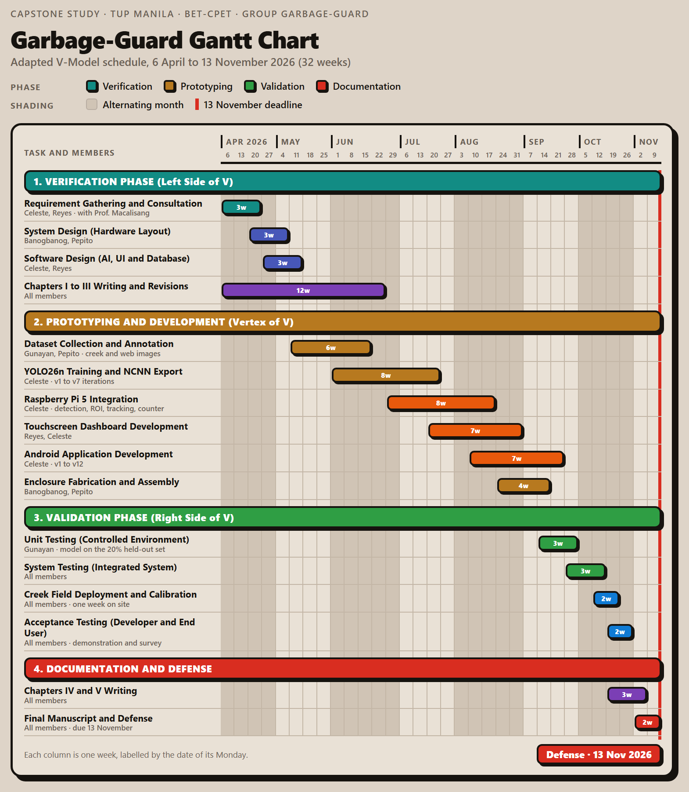

VIII. STUDENTS’ BIONOTE
Brian Jay Celeste, a student enrolled in Computer Engineering Technology at the TUP - Manila and achieved N3 certification in the Japanese Language Proficiency Test (JLPT). He works on software development, artificial intelligence, embedded systems, and electronics as his primary technical focus areas. The study designates him as the main project developer who develops the system architecture and trains the YOLO26 garbage detection model through computer vision, focusing on Android App integration.
Genesis Walter D. Reyes II, a Computer Engineering Student in Technological University of the Philippines. He mainly focuses on his interests in both hardware and software. The study designates him as the second project developer who is the main developer who trained the YOLO26 garbage detection model.
Jade C. Gunayan, a Computer Engineering Student in Technological University of the Philippines. He conducts research testing and statistical analysis to verify the thesis prototype system's trustworthy performance.
King Perth G. Pepito, a Computer Engineering Technology student at the Technological University of the Philippines. His current research project work involves analyzing systems, designing organizational rules, and proofreading research documentation to guarantee the successful execution of the project.
Rodel S. Banogbanog, a Computer Engineering Technology student at TUP-Manila with interest in both hardware and software technologies, also achieved Certification of NCII of CSS and NCII of Electrical Installation. He focuses on creating intelligent systems through his development work. In this study, Banogbanog handles the project fabrication and design actualization.

